
Kingdom of Saudi Arabia English Language

24
Ministry of Education 2nd Grade
Ynababie Al-Hekmah School 1st Term
Date :

Student name :


1- الاختبار ثلاثة أوراق .
2- الإجابة على نفس الورقه .

Reviser | Corrector | Mark in writing | Mark in number
 |  |  |  | The first question
 |  |  |  | The second question
 |  |  |  | The third question
 |  |  |  | The fourth question
 |  |  |  | The fifth question
 |  |  |  | Total

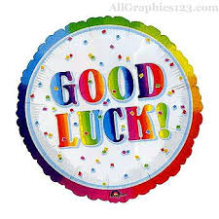


Miss Asma Al-Mjlad
رددي :
سبحانك اللهم اني كنت من الظالمين

The first question :

composition

1- Write about your favorite place in ( 5 ) sentences . Use the following words :
Taif last year west Garden of Hejaz shopping

………………………………………………………………………………………………………………………………………………………………………………………………………………………………………………………………………………………………………………………………………………………………………………………………………………………………………………………………………………………………………………………………………………………………

The second question :
Grammar

A_ Choose the correct answer :
1-You must drive very ( slow _ slowly _ slows _slower ) in front of school.
2- I ( was _ were _ am _ be ) feeling very thirsty so I drank a glass of water now.
3- Be careful . Omar You 're carrying too ( many _ much _ less _ little ) books.
B_ Correct the underlined words :
1- She visiting her grandmother yesterday. …………
You can do it ☺
2- Where did yours leave the car ? …………..…..
3- There is many rice in the kitchen ..………….

C_ Do as shown between brackets :
1- Drink a lots of water ( ask with should )
…………………………………………………………………………………………….

2- Cage ⁄ what's ⁄ a ⁄ for ⁄ ? ( Reorder )
…………………………………………………………………………………………
D_ Give the past tense of these verbs .
1- take …………. 2- find ………….. 3- play …………… 4- cut ……………

Reading comprehension
Q3: Read the passage carefully then answer the following questions :

Mary Celeste

On 5th November 1872 a ship called the Mary Celeste left New York for Genoa in Italy. On the Mary Celeste was a captain and seven crewmen . Nobody saw them alive again . On 4th December another ship saw Mary Celeste . They couldn't see anybody on it . They found a lots of food and water , but no people . They also found the captain's diary . They also did not find the lifeboat . what happen to Mary Celeste and why the lifeboat is not there ? Nobody know .
A_ Answer the following questions
1- what is the Mary Celeste ?
اللهم لا سهل إلا ما جعلته سهلاً
…………………………………………………………………………………………………..……………………..
2- How many people were on the ship …………………………………………………………………………………………….…………………
B- Complete the sentences :
1- you can write about your day in a ………………….. .
2- A ………………….………. Has the most important job on a ship.
C- Chose the correct answer :
1- ( Nobody _ Everybody _ Somebody ) knows what happened.
2- They didn't find ( everybody _ anybody _ nobody ) on the ship.
D_ Who or what the underlined words in line 4 refer to :
1- they …………….. 2- it …………..
__________________________________________________________________________
The fourth question :

_______
Vocabulary

A_ Find the odd word :
1- farmer teacher waiter boy .
2- brother friend mother sister .

B_ Match the words with the pictures :
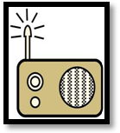

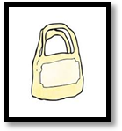
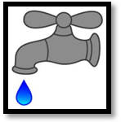

1- plastic bag 2- tap 3- studio 4- radio 5- space ship

C- Choose and write :
Paper cheese chips wool leather

1- potatoes …………. 2- sheep ……….. 3- milk ……… 4- wood …………..

Dictation
The fifth question :

A- Reorder the letters :

1- Cfѐa ……….. 2- apkr ………. 3- othel ……….. 4- bceah………..

B- Complete the missing letter :
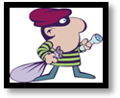


1- bu__gler . 2- wai_er
.

_____________________________________________________________________

Well done !

With my best wishes ☺
Miss Asma Al-Mjlad .

