

Kingdom of Saudi Arabia English Language Exam
Ministry of Education School Year 1435/1436 AH
1st session 1st Term
Time : 2 hours
Al-……… Compound School 3rd Secondary stage
In The Name of Allah, Al-Rahman, Al-Rahim
Q.No. | Page 1 | Page 2 | Oral test | Total Mark | Corrector | Reviser
Marks

اختبار الصف الثالث ثانوي

Name:- ………………………………… رقم الجلوس:______ …………………………….. اسم الطالب:-
Question①: Composition
Write an essay about "Sports" and the importance of practising them :
7

…………………………………………………………………………………………………….…..
……………………………………….………………………………………………………….……..
……………………………………………..…………………………………………………….……..
……………………………………………………..…………………………………………………….……..
………………………………….………………….………………………………………………….………..
……………………………………………………..………………………………………………….………..
……………………………………………………..………………………………………………….………..
………………………………………………………..……………………………………………….………..
…………………………………………………………………………………………………………………..
…………………………………………………………………………………………………………………..
……………………………………………………………….…………………………………………………..
……………………………………………………………………………………………………………….…..

Question②: Vocabulary
A)write the suffix. (-or,-ian, -ist,-er)

6







1-teach___ 2-sail___ 3-technic___ 4-physic__

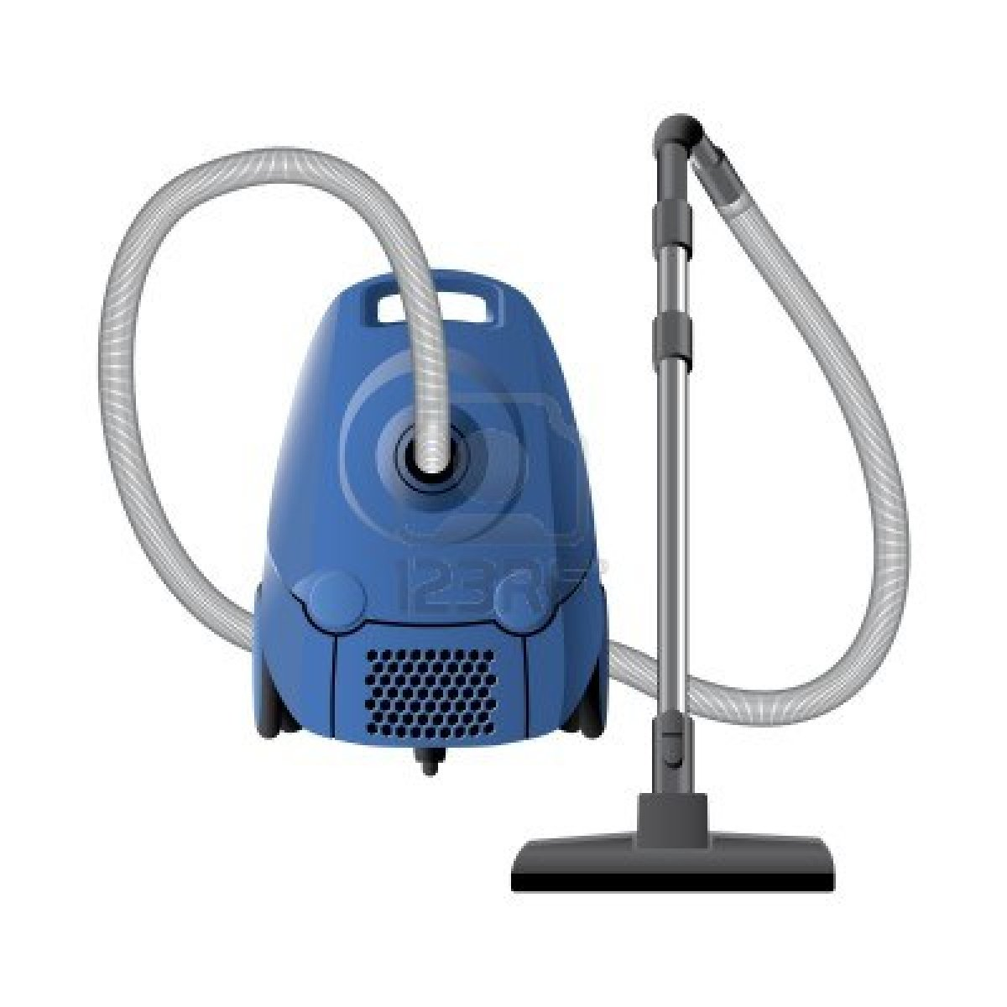
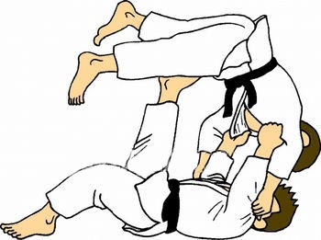
B) Circle the correct word under each picture:



1-( biology – chemistry ) 2- ( flag – coins) 3- (vacuum cleaner – tent ) 4-( boxing – judo ) B) Fill in the blanks using the words in the box:
give up
tiring
fail
rink
refund
1-Nada didn't ……………..…..the exam-she got 90%.
2-you play ice hockey on a …………….…… .
3-It is impossible to beat you. I ……….……………. .
4- Working all day and studying at night is ………………….. .

Question③: Comprehension
Read the passage then answer:
5

My friend , Saleh , and I love going on holiday every summer. We get our tent and
sleeping bags, go to an island and spend our holiday on a campsite. Last year we
wanted it to be different . So , we decided to book a room at a hotel for a change. Unfortunately , it wasn't what we expected . First of all , everything at the breakfast buffet was terrible , so , we never had a nice breakfast. And breakfast is my favourite meal of the day ! The room service was very bad, too. The people were rude and it sometimes took them more an hour to bring our food to the room. Also , the hotel's Wi-Fi connection didn't work and we couldn't send e-mails.
*-Answer the following questions:
1-What do Saleh and his friend love? ...................................................................................................................................
2- What did they decide last year? …………………………………………………………………………………………
3-Did the hotel's WiFi connection work? ………………………………………………………………………………………….
*- Put ( T ) or ( F ) :-
1- Last year they stayed in a campsite. ( )
2- The breakfast buffet was nice. ( )
*- choose the correct answer :-
1-The room service was (bad-good-nice).
2-Breakfast is my favourite (team-food-meal) of the day.
Question④: Grammar
A: Choose the correct word:

6

1- Are you good ( at – in – for ) science?

2- Some people are afraid ( with – of – about )the situation? .

3- Football is the game ( who – where – which )many people play .

4- Students ( must – mustn't – have to) use mobile phones in class.

5- There isn't (anyone – someone – anywhere ) in the shop.

6- Nada did ( such – so ) well in that competition.

B-Do as shown between brackets.
1-He invented dynamite in 1867. ( change into passive.)
………………………………………………………………………….
2- He wishes he …………………… ( has ) a car . (Correct.)

3-I have painted the room. (Report.)
Salim said…………………………………………………………

-X- End of Questions -X-
Best of Luck……………

