Subject: Hobbies
Type:

Time activity:
No. activity:

Classroom:

Student Name:

Use...
"Can – Can't"

- He ………………… using a computer.

- She …………… drawing a picture.

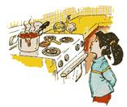

- She ………… cooking the food.

✗

- They ……………… reading.

