Revision Unit 1

1]: Write the names of the given sports and pictures :
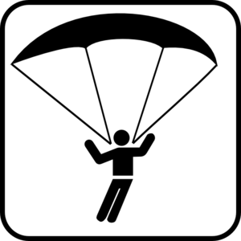
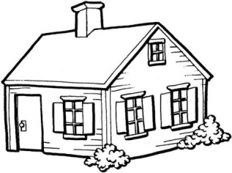
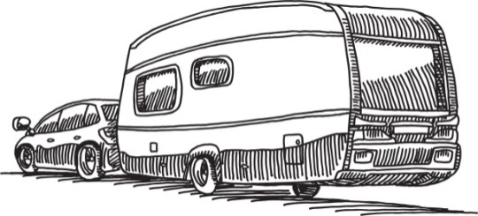
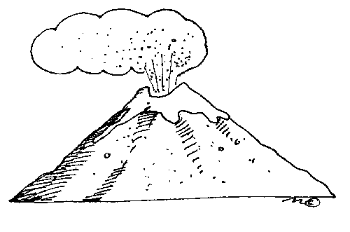

----------------------- ---------------------- ------------------------ --------------------
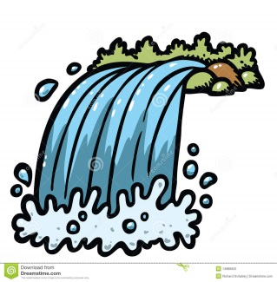
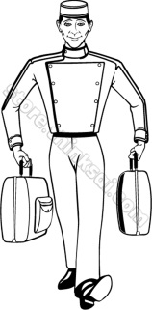
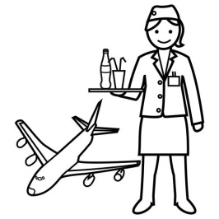
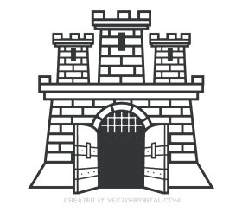
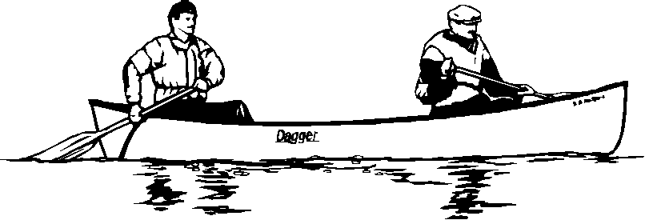

-------------------- -------------- -------------- ---------------- -----------------------

2]: Match the words with their meanings :
Wrecking provide services to
Cater to destroying
Purchase obligatory
Complimentary having official qualification
Certified free of charge
Mandatory buy

3]: Choose the correct answer : [ vocabulary]
a- Our teacher keeps telling us that ( travel –trip – journey ) broadens mind
b- What is the best way to ( reach – arrive – get to ) your friend's house
c- The new holiday ( resort – caravan – cottage ) offers free tennis lessons
d- There are lots of youth ( hotels – hostels ) around the town
e- Your passport is not ( valid- available – partial ) you must have it renewed
f- The cake looked very ( appealing – complimentary ) to be eaten
e- The ( bellboy – flight attendant – receptionist ) took our suitcase to the room
f- Sami has a fish ( waterfall – pond – mosque ) in his garden

4]: Complete by using the correct noun form :
a- We are having a great ( discuss ) -------------------------
b- I accept his ( invite ) ----------------------- and went to the party

5]: Choose the correct answer : [ Grammar ]
a- Samar is looking for some ( information –informations ) about travelling to Japan
b- I don't have ( much – many ) time
c- You ( visit – are visiting ) Turkey this week
d- water ( boil – boils – is boiling ) at 100c

e- We ( go- goes – are going ) for an excursion next weekend
f- Ronaldo (score- scores – is scoring )a goal.
g-There are ( some – any ) oranges in the fridge.
h- Would you like ( some - any ) coffee?
i- There is ( any – no ) cheese.
j- There isn't ( any – no - some) sugar in the tea .

