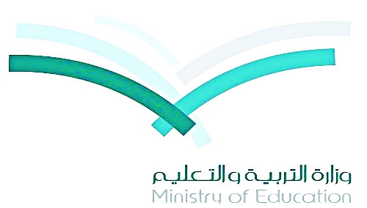

Distribution of the Syllabus - the 2nd Intermediate Grade the 1st Term 1436 - 1437
توزيع منهج اللغة الانجليزية (سوبر قول 3) للصف الثاني متوسط – الفصل الدراسي الأول للعام 1436-1437هـ
6th week | 5th week | 4th week | 3rd week | 2nd week | 1st week
21/12 – 25/12 | 16/12 – 18/12 | 29/11 – 4/12 | 22/11 – 26/11 | 15/11 – 19/11 | 8/11 – 12/11
Who’s Who | Who’s Who | What Are They Making? | What Are They Making? | Are You Here on Vacation? | Are You Here on Vacation?
12th week | 11th week | 10th week | 9th week | 8th week | 7th week
4/2 – 8/2 | 26/1 – 1/2 | 19/1 – 23/1 | 12/1 – 16/1 | 5/1 – 9/1 | 28/12 – 2/1
What Was It Like? | What Was It Like? | Is There Any Ice Cream? | Is There Any Ice Cream? | Favorite Pastimes | Favorite Pastimes
18th & 19th week | 17th week | 16th week | 15th week | 14th week | 13th week
16/3 – 27/3 | 9/3 – 13/3 | 2/3 – 6/3 | 25/2 – 29/2 | 18/2 – 22/2 | 11/2 – 15/2
Final  EXAMS | EXAMS | What’s Wrong? | What’s Wrong? | What Happened? | What Happened?
Principal:-

Teacher :- waleed Al Sqour

