Name.................................................................Lessons 13+14
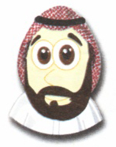
1-Answer;-
1-Is he from Bahrain?

No,............ ...... ......
2- Are they from Saudi Arabia?
Yes, ....... .............

2-Correct the mistakes:-
oman qatar kuwait emirates
................. ................... ................... ...................
3- Complete :

1- He is from Bahrain , he is …………………………….
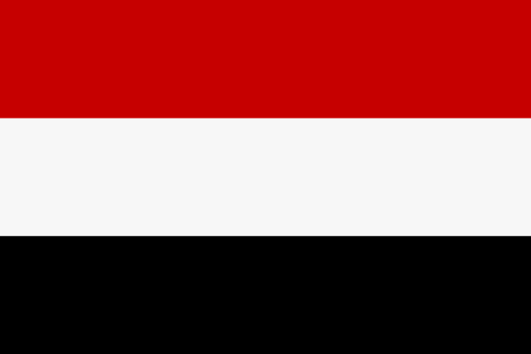
2- she is from Yemen , she is ………………………………

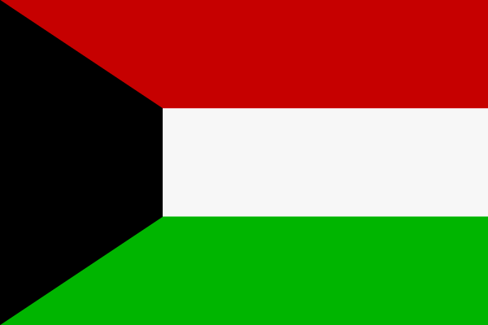
3- He is from Kuwait, he is ………………………….

اتقنت لم تتقن

