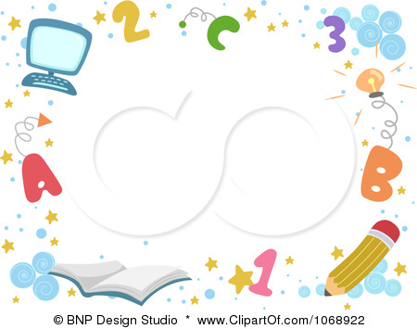
Distribution of the Syllabus For
مدير/ ة المدرسة :أ.

التوقيع :

مشرف/ة المادة : أ

التوقيع :

معلم / ة المادة

التوقيع :

Fifth Grade Second Term 1436 – 1437

6th week | 5th week | 4th week | 3rd week | 2nd week | 1st week
12 / 5 – 16 / 5 | 5 / 5 – 9 / 5 | 28/ 4 – 2 / 5 | 21 / 4 – 25 / 4 | 14 / 4 –18 / 4 | 7 / 4 –11/ 4
Unit 3  Talk time  Rhythms & sounds | Unit 2  Phonics  evaluation | Unit 2  Rhythms & sounds  Words in action | evaluation  Unit 2  Talk time | Unit 1  Words in action  Phonics | Unit 1  Talk time  Rhythms & sounds
12th week | 11th week | 10th week | 9th week | 8th week | 7th week
2 / 7 – 6/ 7 | 25 / 6 – 29/ 6 | 18/ 6 – 22/ 6 | 11 / 6 – 15 / 6 | 26 / 5 – 1 / 6 | / 5 – 23 / 5219
Unit 5  Words in action  Phonics | Unit 5  Talk time  Rhythms & sounds | Unit 4  Phonics  evaluation | Unit 4  Rhythms & sounds  Words in action | evaluation  Unit 4  Talk time | Unit 3  Words in action  Phonics
18th week | 17th week | 16th week | 15th week | 14th week | 13th week
15 / 8 – 19 / 8 | 8 / 8 – 12 / 8 | 1 / 8 – 5 / 8 | 23 / 7 – 27 /7 | 16 / 7 – 20 / 7 | 9 / 7 – 13 / 7
The Final  Exams | The Final  Exams | Revisions | Phonic Practice | Phonic Practice | evaluation

