Worksheet Units:1+2
Grammar:
A-Do as shown between brackets:
1-They usually go shopping.
How often ……………………………………………………….? ( Complete)
2-Amal sometimes ( watch )……………………………………TV.(Correct the verb )
3-He wore a jacket yesterday.
……………………………………………………………………..…..(Change to negative )
4-We ( go ) ………………………………. to the mall last week.(Correct the verb )
5-Do they read stories every week?
No,………………………………. ( Complete )

B-Choose the correct word:
1-Did you ( drink – drank – drinks - drinking ) coffee?
2-She always ( eat – eating – ate – eats ) pizza.
3-How ( often – much - many – long ) does she arrive at work on time? Always.
4-I used to ( played – play – plays - playing ) football.

Vocabulary:
A-Write the correct number under the correct picture:
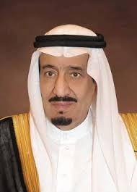
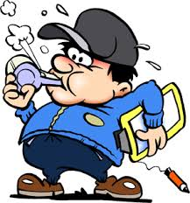
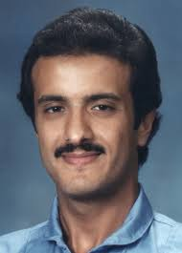
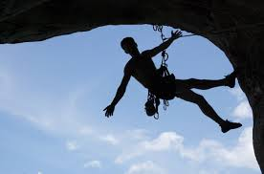
1-coach 2-rock climbing 3-prince 4-crown prince 5-swimming

B-Match with numbers:
1-exercise freak | ………….a-important opportunity
2-a baby | …………b-to appear unexpectedly
3-big break | ………..c-donate
4-to turn up | ………..d-appointment
5-give to charity | ……….e- outstanding
6-arrangements to meet | ……….f- encourage
7-excellent | ……….g- someone who exercises alot
8-support | ……….h- infant
9-got together
Orthography:
A-Fill in the missing letters:
1-tw……..n 2-employ……..e

B-Choose the correct letters:
1-ad…………….t ( dic – dac – - duc - dec )
2-ex……………..se ( irci – arci - rcici – erci )

C-Choose the correct word:
1- a-bloud b- blood c- blaod d-plood
2- a-crown b- crawn c-croun d-krown T:Nouf

Worksheet Unit:3
Grammar
A-Do as shown between brackets:
1-My friends ( wait )……………………………………………….. for me now.( Correct the verb)
2-They are watching a film .( Change to negative )
………………………………………………………………………………………..
3-Is he traveling next week ?
Yes,……………………………….. (Complete )
4-He (fly )……………………………………………………… to Jeddah tomorrow. ( Correct the verb )
5-She will read a book. ( Use going to )
………………………………………………………………………….
B-Choose the correct words:
1-He is going to ( write – writes – wrote – written ) a book.
2-They ( are eating – will eat – eat – ate ) now.
3-You ( playing – played – plays – will play ) tonight.
4-We will ( visited – visit – visiting – visits ) our uncle next Sunday.

Vocabulary:
A-Match with numbers:

1-unique | …………a-traditions
2-heritage | ………….b-special
3-buzzing | ………….c-things for sale
4-weather | …………..d- busy and lively
 | ……………e-climate

B-Write the correct number under the correct picture:
1-baggage 2- liquids 3- travel agency 4- airport 5-visa
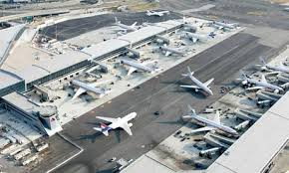
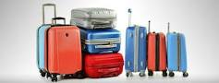

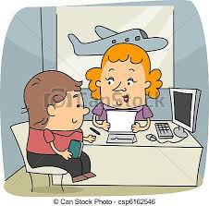

Orthography:
A-Fill in the missing letters:
c……mpany

B-Choose the correct letters:
uni……………ty ( varci – verci – vurci – versit)

C-Choose the correct word:
1- a-mistake b-misteke c-mistakke d-micetake
2- a-daialect b-dialikt c-dialict d-dialect

T:Nouf

Worksheet Units: 4+6
A-Do as shown between brackets:
1-She ( leave )…………………………. Riyadh since 2001.( Correct the verb )
2-He has been a doctor for 2 years.
How long…………………………………………..?( Complete )
3-I have known my friend ………………….. four months.( Write since or for )
4-Hala is ( tall ) …………………. than the teacher. ( Write the correct form of adjective)
5-Planes are ( fast ) …………………………..way to travel in the world. ( Write the correct form of adjective)
6-Rome is amazing and so is Paris.( Use as ……as )
…………………………………………………………
B-Choose the correct words:
1-They have studied ( for – since – yesterday – already ) three years.
2-We ( visit – visited – are visiting – have visited) Jeddah in 1999.
3-Huda’s mark is ( good – better – the best – bad ) in the class.
4-A village is ( quiet – quieter – quietest – the quietest ) than the city.
5-Sami is as ( tall – taller – tallest – the tallest ) as his father.
Vocabulary:
A-Match with numbers:

1-settle down | ……a- a way of doing things
2-teqnique | …….b-actions or events in a particular order
3-sequence | …….c- stop in the middle
4-interrupt | …….d-a new way of doing things
5-innovation | …….e-a small model
6-miniature | ……..f-get married
 | ……..g-succeed in doing something

B-Write the correct numbers under the correct pictures:
1-light bulb 2– paper clip 3– bullet train 4– printer 5 – cell phones 6-bus

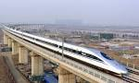
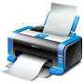
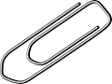
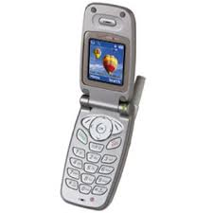
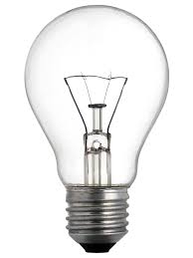

C-Write the opposite:
1-dangerous#................................... 2-public#................................ 3-noisy#..................................
Orthography:
A-Fill in the missing letters:
1-gl…….bal 2-to…….n

B-Choose the correct letters:
1-s………….rb ( abur – ubu – obu – abo )
2-inven……….n ( tio – tao – toi – tao )

C-Choose the correct word:
1- a-audance b- aodiance c-audience d-audaiance
2- a-citizen b-sitizen c-citazn d-citizin
T:Nouf

