المملكة العربية السعودية  وزارة التربية والتعليم  إدارة التربية والتعليم بمنطقة ..........  لعام 1434 – 1435 هــ |  |  | 
 |  |  |  |  | المادة | E | الدرجة
 |  |  |  |  | الصف | م2
 |  |  |  |  | الزمن | 1.30 | رقما | كتابه
 |  |  |  |  | اختبار  الفصل : الأول  الدور : الأول |  | رقما | كتابه
اسم المصحح |  |  | توقيع
المراجع |  |  | توقيع
 | أسم الطالب: ....................................... الصف: ( الثاني / ) رقم الجلوس: ................
================================================
1) - Comprehension

READ THE FOLLOWING PASSAGE THEN ANSWER THE QUESTIONS :

Hamad lives in Riyadh. He is 17 years old. He is 170 centimeters tall. He is a student. His father is a doctor. His favorite food is fruits . His favorite subject is history. In his free time he plays computers games.

5
A-: ANSWER THE FOLLOWING QUESTIONS:
1)- What is Hamad’s favorite subject ?
- ………….…………………….…………….………..
B-: CHOOSE :
1)- His favorite food is …………….
a- breads b- sweets c- fruits
2)- His father is a ……………..
a- teacher b- student c- doctor
C-: Put ( T ) for true sentences and ( F ) for false sentence:

1 )- Hamad is 16 years old. | ( )
2 )- He plays football in his free time. | ( )


4
2)– Vocabulary

** WRITE THE CORRECT WORD UNDER EACH PICTURE:

a. Pilot | b. Shake hands | c. Using computer | d. swimming

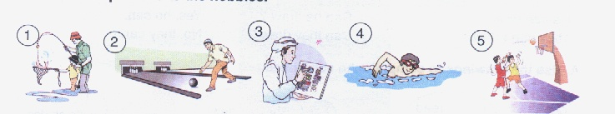

6
3)- Grammar

** CHOOSE THE CORRECT ANSWER:
1)- He Can [ play – playing – played ] football.
2)- [ you – He – They ] was in the library yesterday.
3)- Ahmad likes [ write – writing – wrote ].
4)- Did you study well? Yes, I [ do – does – did ].
5)- [ When – Where – What ] do you exercise ? In the morning..
6)- No, he [ are not – is not – are ] .

7
4)- Information Questions :

** MATCH ( A ) WITH ( B ) CORRECTLY:

{ A } |  | { B }
1 )- Truthful means | .......... | - international.
2 )- 1592 | .......... | - writes for newspapers
3 )- journalist | .......... | - hug , bow , pat the back.
4 )- It's one forty five. | .......... | - Fifteen ninety-two
5 )- teacher | .......... | - work in school.
6 )- Greetings | .......... | - says the truth
7 )- English language | .......... | 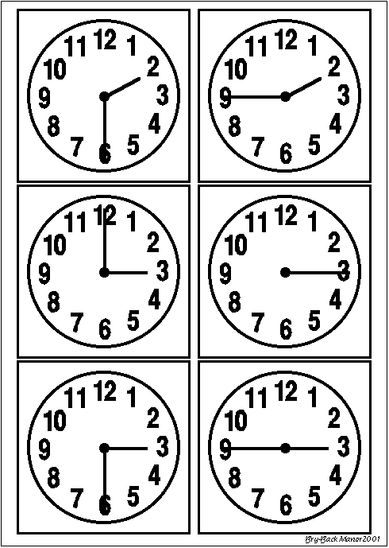  -

4
5)- Dictation

** FILL IN THE MISSING LETTERS :
l | a | i | o

1 )- Spent t__me with my fami__y.
2 )- I like pl__ying f__otball.

4
6)- Handwriting

**Copy the following sentences TWICE :
You can only go as far as you push .

With My Best Wishes

