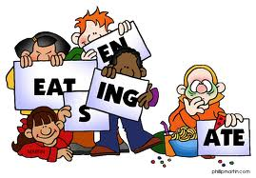
3b Grammar
1/ He sometimes reads the newspaper,………………..……………….?
2/ You are Indian, ………………..………………………..…….?
3/ Peggy didn't use the pencil, ………………..………………..……….?
4/ The boy is from Turkey, ……………………….…..……………….?
5/ He's been to Texas, ………………..………………………….?
6/ Peter played handball yesterday, …………………..……………….?
7/ Kevin will come tonight, …………………………….……………….?
8/ They have cleaned their bikes, ………………..………...…………….?

1- Her dad works for TAP, a) Have I ?

2- We didn't see Jake, b) didn't he ?

3- Her mom is a lawyer, c) do you ?

4- He left early, d) won't they ?

5- You don't know him, e) doesn't she ?

6- I haven't told her, f) did we ?

7- They will share it, g) isn't she ?

8- She misses her mom, h) doesn't he ?

Match :

Choose :

1. You're coming to the party, ___?
a. aren't you
b. isn't you
c. shouldn't you
2. It wasn't very difficult, ___?
a. wasn't it
b. isn't it
c. was it
3. Tom is getting something for Sue, ___?
a. wasn't he
b. isn't he
c. was he

b. isn't it
c. will it



