

1-Grammar:
A - Do as shown between brackets :
1- Omar / want to talk to Fred?
Why did Omar want to talk to Fred?
( Make a question with Why )
B - Choose the right answer:
1- Fred ( is - are - do ) drinking apple juice.
2- They ( is - are - was ) travelling by plane.
3- The boys got wet and ( caught - catching - catch ) a cold.
4- He is ( go - went - going ) to England.
5- We produce too ( much - many - some ) rubbish in modern cities.
****************************************************************************3-Vocabulary :
A-Mach the words with the correct pictures :

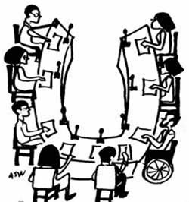

( pocket money- committee - award )

award..................................... pocket money............................ committee

4- Spelling:
A - Choose the correct letters:
1- scholarshi....... ( w – a – p ) 2- con.......ratulations ( g – l – x )
2- .........pecially ( s – u – o ) 4- inclu.........e ( e – d – h )

