Test 1 Second year 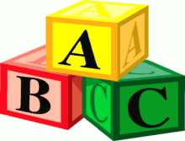
Name:……………………………….
Class………………………………..

1-Write about yourself :
Name –age – tall – kilos – meter - weigh – person – kind – interested
…………………………………………………………………………………………………………………………………………………………………………………………………………………………………………………………………………………………………………………………………………………………………………………………………………………………………………………………………………………………………..
2-Read the passage then answer the questions:
The Arabian Oryx are very rare animals. There are about 1000 animals in the world. They live in the Arabian desert in Saudi Arabia and other countries. They are white and have two long horns .They eat grass. They weigh about 70 kilos.
A-Where does the Arabian Oryx live?.....................................................................................................
B-Choose:
1-The Arabian Oryx eat ( apples – eggs – grass )
2-Their color is ( black – white –pink )
C-Put right or wrong:
1-They weigh 70 kilos ( )
2-They have three long horns ( ).

3-Grammar :
Choose:
1-I go to school ( in – on – by ) foot.
2-Fatimah is nice but shahad is even ( nice – nicer – the nicest ).
3-She is afraid ( at – of – with ) snakes .
4- How ( much – many –any ) books do you have ?

Do as shown between brackets :
1-She will make a cake .( write a question ).
……………………………………………………………………..
2- Huda – Is – ? - TV.- watching ( Rearrange )
……………………………………………………………………..
4-Vocabulary :
Match the following :
1-staff ( )- gives to people
2-old ( )-tall and thin building
3-Tower ( )-Age
4-generous ( )-people who work in hotel
5-lift
Put words under pictures :
Ballon - cheetah - foot - elephant - scooter
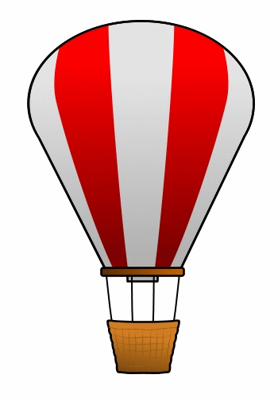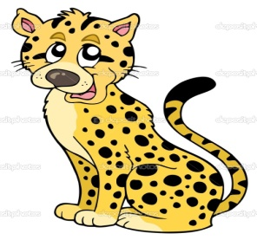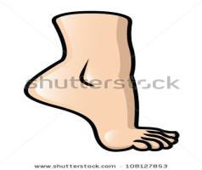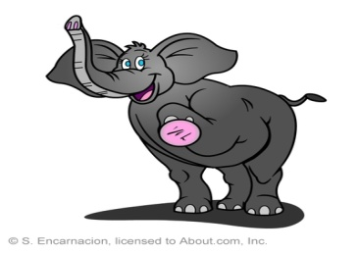
…………………………………… …………………… …………………… …………………..
5-Orthography :
Fill in the missing letter :
( m – z - w – g – o )
1-Book _ orm
2- pri _ e
3- Infor _ation
4-hi _ ht

Good luck
Teachers of the subject

