Lift off 4 2nd Term Unit8 1-Vocabulary: A-Write the correct word in the blanks:
1-measure 2-spices 3-until 4-float 5-expermints 6-boil 7-dentist
s

1-Cumin and pepper are kinds of -------------------------
2-If the eggs are bad , they ------------- on the water .
3- The science teacher usually makes ------------------ in her lessons .
4- To make tea -----------------the water ,add tea and sugar .
5 – If you have a toothache you have to go the ------------------
6- Cook the onions - ---------------they are brown.
7- You can use a ruler to -----------------------the length of things.
B-Write the correct word under each picture
1-dentist 2-peel 3-mix 4-brush

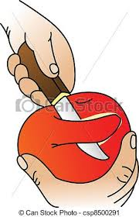
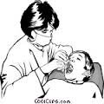

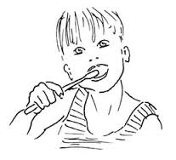

---------------- ------------------- ------------------- ---------------
2-Grammar:A)Choose the correct words:
1-They always {pray – prays –prayed } on time.
2-She usually {help– helped –helps } her mother.
3-He never {sleep – sleeps–sleeping } late.
4-He always {do – does–did } his homework .
5- Write an e-mail. Send it{for – to – of } Reem.
6-I saw {a – an – the } woman giving {a – an – the } young boy {a – an – the }
ice cream {a – an – the } boy looked very pleased .

B)Do as shown between brackets
# Ahmed sometimes go to school late . {Correct the underlined word}
-------------------
1-the /present/Sara/to/ give {Order the words to make sentences }
C) Use a/ an /the
1-…………………..board in the class room is big and white.
2-……………………. student who is sitting in the back is good.
3-My sister gave me ……………..ice cream.

You are my best students

