
Kingdom of Saudi Arabia English language final Exam
The Ministry of Education Traveller ( 1 )
General Directorate of Education Time : 3 hours
Madinna Munawra Date : 27 / 12 / 1437AH
The 32nd Secondary School

Question | Mark | Corrected by | Revised by | Total
Composition
Comprehension
Grammar
Vocabulary
Student's Name:___________________________ Seat No. ( )
I. Composition

8
Complete the following e-mail, describing your new house.

To: ------------
From: -----------
------------------,
-----------------------------? I'm writing to tell you about my new house.
It's great! --------------------------------------------------------------------------------------------------------------------------------------------------------------------------------------------------------------------------------------------------------------------------------------------------------------------------------------------------------------------------------------------------------------------------------------------------------------------------------------------------------------------------------.
-----------------------------------,
-----------------
-1-

11. Comprehension

12

Read the following passage, and then answer the questions below:

Fast food is the food sold in many expensive restaurants as McDonald’s, Kentucky and Hardees . It is called “Fast” because you get your food very quickly. It might take you only twenty minutes to get in, order your meal, eat it and leave. The kinds of food served in those restaurants are beef and cheese burger, hot sausage, fried chickens and french fries which are full of fats and carbohydrates. A fast food meal also includes a soft drink like cola, soda, juice or milk shake.
The problem is that such kind of food is so rich in fats, sugar, salt and cholesterol. Doctors advise us to eat less fast food, more salads because they are good for health, and drink less sugary juice. They say that fast food is a reason for getting fat and it might cause some people to get heart problems.
Questions:
1- Where is fast food sold?
-----------------------------------------------.
2- What is fast food rich in?
------------------------------------------------.
3- Choose the correct answers:
a- You can get fast food very ------------------.
- slowly - late - quickly
b- ---------------- is a kind of soft drinks.
- cola - burger - hot sausage
c- Which picture shows burger?
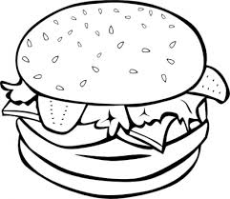
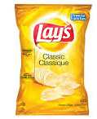- - -

d- beef is the meat of ------------
- - -

e- they in line (10) means:
- doctors - restaurants - sick people
f- it in line (11) means:
- soda - juice - fast food
4- Write (T) or (F):
( ) a- Salads are good for health.
( ) b- Fried chickens are kinds of fast food.
-2-
( ) c- Fast food can cause heart problems.
( ) d- Having more sugary juice is healthy.
111. Grammar

10

A) Choose the correct answers:
1- I can ( painting – painted – paint ) my room.
2- (Do – Does – Did ) you wake up early every day?
3- Whose car is this ?It's ( my – me – mine ).
4- He hates [ plays – playing – play ] in the street.
5- There is not ( some – any – no ) salt in the rice.
6- Do you want [ a – an – the ] cup of tea?
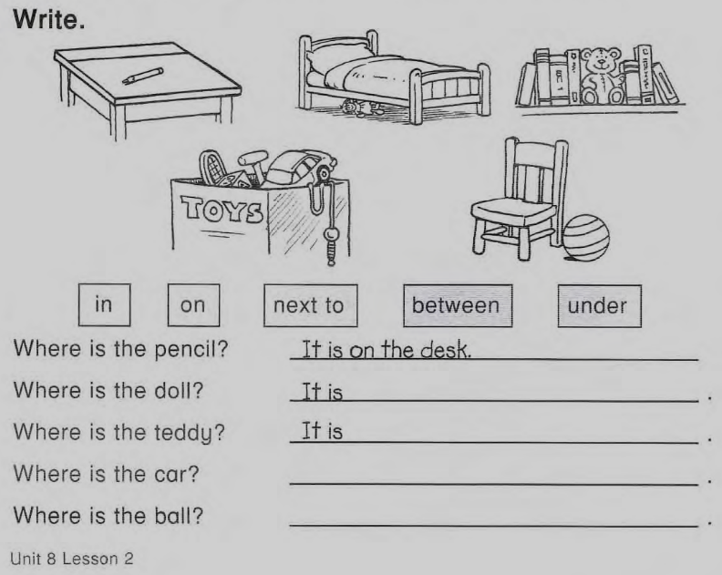
7- How ( much – a little - many ) meals are there in the day?
8- The pencil is ( in – on – under ) the desk.
9- I like cherries [ but – so – and ] I don't like cherry ice cream.
10- My work is ( on – in - at ) the morning.
11- Ahmad speaks Japanese very ( good – bad - well).
12- They ( didn’t – don’t– doesn’t ) sleep early last night.
B) Do as shown between brackets:
1- she – the house – Does - ? – clean (Rearrange )
-------------------------------------------
2- Did Ali fail the exam ?
No, ------------------------- (Complete the answer)
3- He / hurry. ( Use should )
-------------------------------------------
4- There is water in the fridge. ( Complete the question)
Is ------------------------------?
-3-

IV. Vocabulary

10

A) Choose the correct words:
1- He is very [ busy – hungry –funny ]. He can't wait till lunch break.
2- Can I [ check – take up – interview ] my e-mails on your computer?
3- My tooth hurt. I have [ backache – temperature – toothache ].
4- He wants to take a new [ course – age – young ] at university.
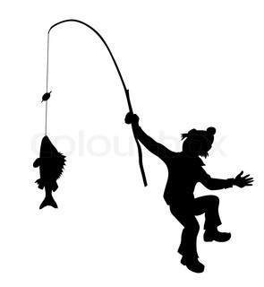
B) Match pictures with suitable words:
c
e
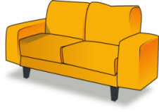
1- fishing : -------------
2- mop the floor: ----------
b
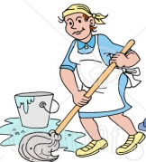
3- sofa: -----------
a

4- rainy: ---------
d
C) Match (A) and (B):
(A) (B)
1- clean ( ) a – room
2- living ( ) b- an exam
( ) c- the window
===============================================================================
Good Luck

-4-

