
General Revision

Comprehension

Read the following passage then, answer the questions:
Ali is a good schoolboy . He is 13 years old . He lives in Al-Madina with his family . His father name is Bader . His father is a teacher . Ali and his family have a big house . It has four bed rooms, three bathrooms, a living-room and a dinning room . Ali loves his family . He likes English subject .
A- Answer the following questions:
1- How old is Ali ?
……………………………………………………………………………………………………….
2- What is his father's name ?
……………………………………………………………………………………………………….
B- Choose the correct words:
1- He lives in [ Jeddah - Al-Madina ].
2-His father is a [ doctor – teacher ].
C- Put (  ) or (  ) :
1- He likes English subject . { }
2- Ali doesn't love his family . { }
***************************************
Read the following passage then, answer the questions:
Miss Layla is a teacher in a kindergarten. She teaches little children. She has
twenty-one students in her class, ten boys and eleven girls. She likes her students; and her students like her. She's very patient and helps them a lot. She's a very good teacher.
A- Answer the following questions:
1- How many boys student are there in the class ?
……………………………………………………………………………………………………….
2- Is Layla a teacher?
……………………………………………………………………………………………………….
B- Choose the correct words:
1. Miss Layla teaches ……………..
a. little children b. young students c. old students
2. She has ten boys and eleven………………
a. teachers b. girls c. farmers
C- Put (  ) or (  ) :
1- Miss Layla works in a kindergarten . { }
2- She has forty student in her class . { }
****************************( 1 )****************************
Information Questions

A- Answer the following questions:
1- What is the weather like today ?
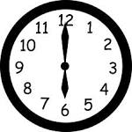
It's ……………………………………………………………
2- What time is it ?
It's ……………………………………………………………….
3- What is your favourite food ?
I like …………………………………………….
4- What's the matter ?
I'm ………………………………………………………
2- How are you ?
………………………………………
3- Hi. My name is Layla :
It's …………………………………………………., Layla .
4- What is your father's job ?
He is …………………………………………………


C- Put (  ) or (  ) :

1- Fred and Nina are twins . ( )
2- Dave's family comes from Britain . ( )
3- Omar is Dave's son . ( )
4- Nina is Dave's mother . ( )
5- Ibrahim's family comes from Saudi Arabia . ( )

***************************************************
Grammar

A –Choose the correct answers :
1- It is ( a - an ) car .
2- It's ( a – an ) air-plane .
3- He is ( sleep – sleeps - sleeping ) in the bed now.
4- They have a car. ( Her – His – Their ) car is new .
5- She has a pen . ( Her – His – our ) pen is red .
6- She ( cooks – cook – cooking ) kabsa .
7- He ( am - is – are ) praying in the mosque .
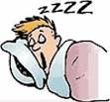
B - Do as shown between brackets :
1- Is he sleeping in his bed ? {Complete the answer } Yes ,…………………………………

2- often / milk / He / drinks . { Rearrange the sentence }
………………………………………………………………….
3- Thank you for ( visiting ) me . { Correct the verb }
……………………………………………………………….
4- Ali is ( watch ) T.V . { Correct the verb }
**********************************************************
Vocabulary

A - Match :
wear coat |  | Penny is Fred's …… | 1
Seasons |  | Ibrahim is wearing …….. | 2
chips |  | I don't like ……… | 3
thobe |  | winter is a ……. | 4
wife |  | I'm cold ……. | 5

B- Write the correct word under each picture :
Juice –midnight -glass – policeman – computer –kitchen- T.V – shirt-children hungry - sunny – kebab -picnic






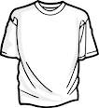

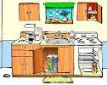

…… …...…… ................ …....... ................ ………… ………… …………….






………… ………. …………. …………. …………

A - Give the opposite : ( never - north – dry - midnight ).
1-Midday X………… 2- wet X ………………….. 3- south X …………… 4- always X ……………………

A- Write the missing letters :

 |  | 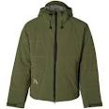 |  |  | 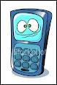
Ch…ps | Piz…a | Co….t | s…n | Wi….dy | Mo…ile ph…ne

( 3 )
B- Unscramble the words :

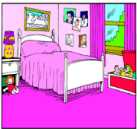  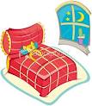 |  | 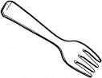 |  | 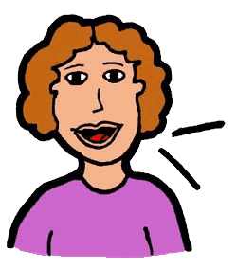 | 
Romodeb  ……………… | derit  …………. | kfro  ………… | mareca  ................. | fiew  …………. | toh  …………..

************************************************************************

5 - Copy the following:

I love my home very much .

( 4 )

