ورقه قياس مهارات الصف الخامس
Name/……………………………………………..
period | Skill Nu |  | The skill,وصف المهاره |  | اتقنت |  | لم تتقن
 | 41 |  | Write short simple words to complete paragraph
 | 42 |  | Write short simple sentences to convey basic personal infomation
 | 43 |  | Apply basic rules of punctuation capital letter ,commas full stop
 | 44 |  | Write short answer to written guestion
 | 45 |  | Refer to people and things using demonstratives { this, that,these.}
 | 46 | Link ideas with commas and and

Complete :
scary Big long
Elephants are ……………………crocodiles are……………………and snakes are …………
***************************************************************************************
. Complete

1-What is your name?
My name is ……………………………

2- How old are you ?..........................................
I am 10 years old - I am a student

3-Where are you from?................................................
I am from Saudi Arabia - I am from kuwit
***********************************************************************************
complete: choose and
{ When_ when} you see a red light__ stop__ stop__ stop__

{when - When} you see a yellow light__ wait__ wait__ wait__
***************************************************************************************
Choose:
this- that- these -
……………….is a monkey. 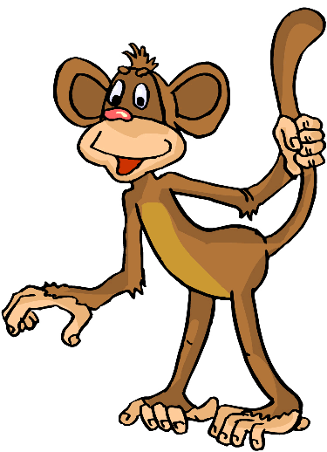 .is koala...............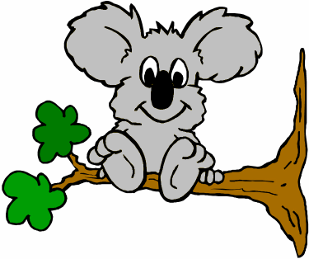
………………are elephants. 
*****************************************************************************************
Choose:

Zebras are black ………... white { and - but }

Walk straight …………….. Turn left{ , __ and }

