اسم الطالبة :---------------------------------------- الصف 3 :- /

Read the following passage then answer the questions in complete
sentences:-

1- My grandmother grew up in a small town . Her house didn't have electricity ,
2- and her family didn't have a telephone . She went to school far from her home.
3-Her parents didn't have a car so she had to walk . After school she took care of
4-her brothers and sisters. When my grandfather married my grandmother they
5-bought a farm and built a big house for their family . They had six children . My
6- grandparents didn't have a lot of money , but they gave their children a lot of love. They had a good life .
A-Questions :
1- Who did her grandmother take care of ?
………………………………..………………………..…….
B-Choose the right answer :
2- In their house they didn't have ( chicken – electricity – radio ).
C-Put ( ) or (  ) :
4- Her grandmother went to school. ( )
5-They had a new car. ( )
6- In line 2 She refers to  her mother  her sister  her grandmother
.
II-Grammar :-
A-Write ( who ) or(which) ( when) (while) to fill in the blank :-
1-The computer__________ I bought doesn't work well .
2- The doctor__________ sites at the front was very happy.
3- I finished reading the book _________ I was riding the bus.
4--She was cooking dinner _________I arrived .

B- Choose the right word :-

1-I have already (do ) (did) (done ) my home work .
2-No I haven’t cleaned the room ( yet) (already )( just)
3- I avoid (eat )( eating ) ( ate ) junk food .
4-Have you already( wash )( washed( washing )the dishes ?


IV-Vocabulary

A-Write the word under each picture:- ِ

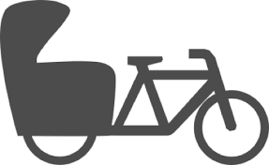



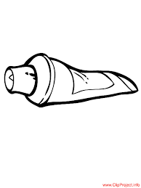

------------------------------------------------------------------------------------------------------------------

B--Choose the correct meaning of the following :-
Isn’t polite 1-poverty
does things well 2- reduce
being poor 3-Afahionable
dress well 4- An efficient
enjoys sports a lot 5- An athletic
6-of course answer yes
make less 7- clever
intelligent 8-A rude-
9-talkaktive


Dictation:

Write the words you hear :--
1---------------------- 2-------------------------

3------------------------ 4----------------------------

