

30

30
Kingdom of Saudi Arabia
Ministry of Education
Tabuk Educational Zone
The 1st Intermediate school

The Final Exam
First term
First Session
1436-1437 H
Second grade

24

24

24

Final exam for 2nd Grade intermediate (-1436 / 37 A.H.)
Seat No: ……….................................................................. : s nameۥStudent

+

6

6
Reviewed by | Corrected by | Marks | Question’s No.
 |  |  | Question 1
 |  |  | Question 2
 |  |  | Question 3
 |  |  | Question 4
 |  |  | Question 5
___24____  24 |  |  | TOTAL

5

5

I- Composition
Q1: Complete this paragraph about your favourite place using the words in the box :
once
Eiffel Tower
previous summer
Paris in France
definitely
exciting

My favourite place is Eiffel Tower. It is in Paris in France. I have been there once. I went there in the previous summer. It's really exciting! It's definitely my favourite place.
Any suitable answer for the student .
2marks for ideas - 1 for structure - 2 for writing techniques

1
II- Comprehension

5
5
Q2: Read the following passage then, answer the questions:
Water is important for us because we need it for drinking and farming, but in the most of the kingdom , there is only about 10 centimeters of rain in a year .
There are five ways of increasing our water . First , we can use dams. Every winter , a lot of water runs through our valleys to the sea. We can stop this water by building high walls across the valleys. There are now several dams in the kingdom . The biggest is Wadi Jizan .
We can take water to dry areas by digging canals . Water runs along these canals and reaches land which has no water . This is called irrigation. We can also use the water in the sea . There is too much salt in it for drinking or for farming. But the government has factories for taking the salt out of sea water. In inland areas , we also get water by digging deep wells. These go down to underground lakes . Some of the water has been in these lakes for thousands of years.
Lastly, We use water towers for storing water . These stop the water from evaporating . The most famous one is in Riyadh .
A- Answer the following questions:
1- Why is water important ? (1 m)
Water is important for us because we need it for drinking and farming.
2- How can we take water to dry areas ? (1 m)
We can take water to dry areas by digging canals.
3- Why do we use water towers ? (1 m)
We use water towers for storing water .
B- Choose the right answer :
1. We use ( dams - wells ) to stop water in the valleys . (½ m)
2. Factories take the salt of ( rain water - sea water ). (½ m)
C- Put ( T  ) or ( F  ) :
1- There are four ways of increasing our water. ( F  ) (½ m)
2- The biggest dam in the kingdom is Wadi Jizan . ( T  ) (½ m)

2
III- Grammar

6

6
Q3: A- Choose the correct answers :
1- Whose is the parrot? It is ( Nina's - Ninas - Ninas' ). (½ m)
2- You must drive very ( slow - slowly - slows ) in front of a school. (½ m)
3- Yasser ( is not - didn't do - aren't ) much work on Wednesday. (½ m)
4- Nina couldn't ( saw - see - seen ) Davey. (½ m)
5- Her sister has ( fewer - less - many ) rice. (½ m)
6- She has ( be - being - been ) there three times. (½ m)
7- What are the shoes made ( on - of - to )? (½ m)
8- Where is my bag? I can't find ( them - her - it ). (½ m)
B - Do as shown between brackets :
1- Ahmad / play / football. (1 m)
Could Ahmad play football?
(Make a question with Could )
2- I can ( swimming ). (1 m)
I can swim.
( Correct the verb )

5

5
IV- Vocabulary
Q4: A- Give the opposites :
1- Put on # take off. (½ m) 2- come in # go out. (½ m)
2- get up # go to bed. (½ m) 3- go to sleep # wake up. (½ m)
B- Put the right words under the right pictures:
captain – bee - bag – fire – window - coal - ambulance
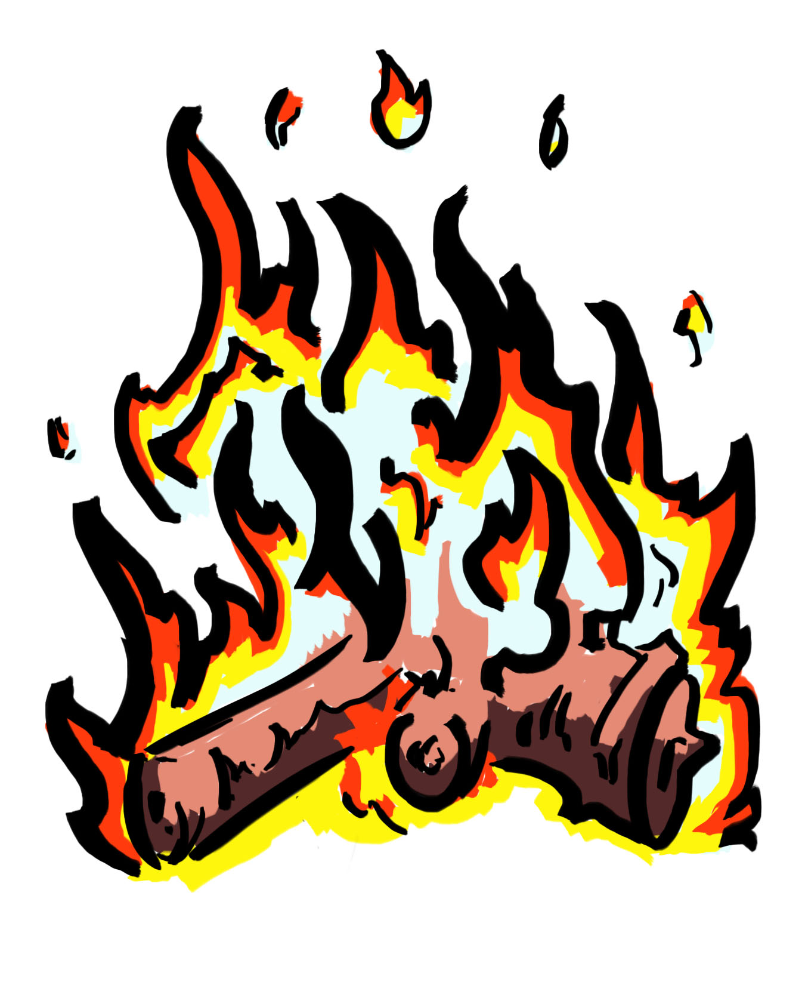
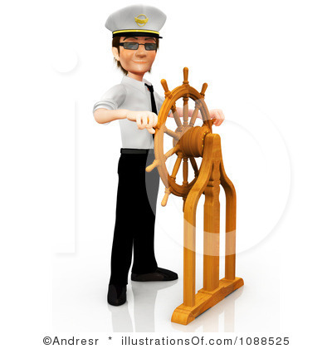
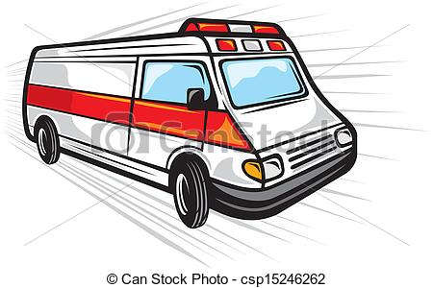
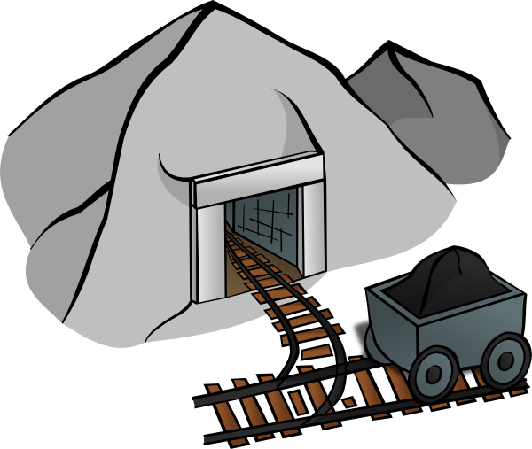
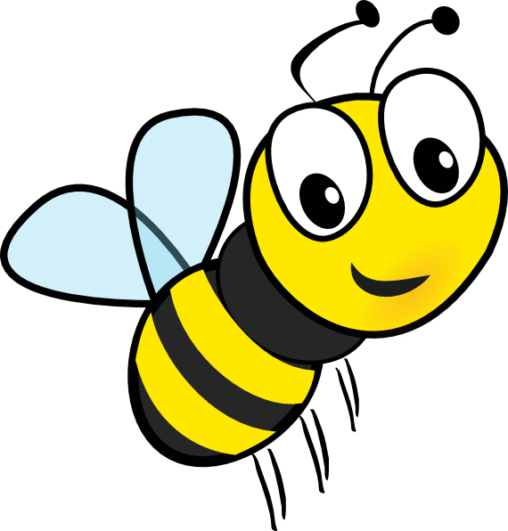


Fire ambulance captain coal bee window
(½ m) (½ m) (½ m) (½ m) (½ m) (½ m)

3
V- Spelling

3

3

Q5: A- Reorder the letters :
1-nfuny funny. (½ m) 2- xtie exit. (½ m)

B- Complete the missing litter :

 |  |  | 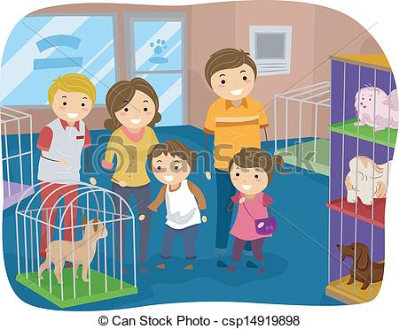
Award (½ m) | Spaceship (½ m) | Baker (½ m) | Pet shop (½ m)
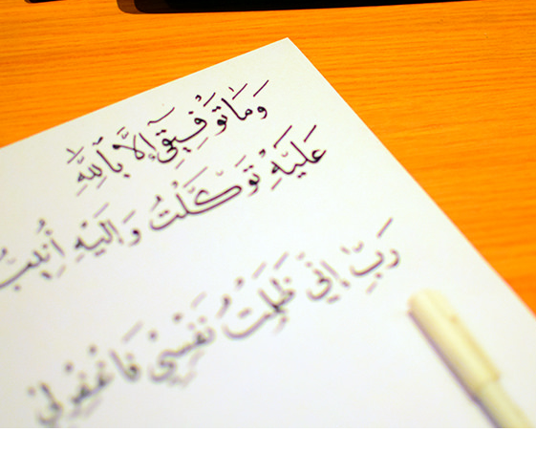

4

