In the name of Allah, most gracious most merciful
Term :1st  Session : 1st |  |   Kingdom of Saudi Arabia
Year : 1433- 1434 |  | General Administration for Education in  Al-Qassim /Buraidah
Grade : Second |  | General Administration for Education in  Al-Qassim /Buraidah
Time : 2 hours |  | English Language/Full blast 3
Pages : 4 |  | The 25th Intermediate School
الاسم ------------------------------------------------ رقم الجلوس ------------------------
أسئلة نهاية الفصل الدراسي الأول الدور الأول لصف ثاني متوسط 1433-1434

Question | 1  COMPREHENSION | II.  Information  questions | III.  Grammar | IV.  VOCABULARY | V.  Spelling | VI.  HandWriting | Total
Mark | 4 | 6 | 5 | 6 | 4 | 5 | 30
Student's
mark
Corrector's name & signature: Reviser's name & signature:
---------------------------------------------- -------------------------------------
I. Comprehension
Read the following passage, then answer the questions below:
Last summer my family and I went to Egypt. At the beginning of our trip, we went on a cruise on the River Nile. We left Cairo on Monday morning and got back on Thursday evening. It was a wonderful experience. Then we stayed in Cairo for five days. We went sightseeing and of course we went to the Egyptian Museum, too. There were so many interesting things to see there. We also visited the Pyramids of Giza and took lots of pictures. They were amazing! My parents and I also tried camel riding. It was lots of fun. My brother didn’t want to go anywhere near the animal. You see, he was afraid. I really want to visit Egypt again. It’s beautiful and there are many things to see and do there!

Answer:
1.Where did the writer and his family go last summer? ________
……………………………………………………………… 4
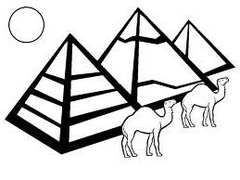
2. Did the writer’s brother enjoy camel riding?
……………………………………………………………..

Complete:
1-They went on a cruise on the …………………….
2-They went sightseeing like …………………………………

Put (True) or (False)
1-They stayed in Cairo six days ( )
2- Cairo is the capital city of Egypt ( )

__________________________________________

II. Information questions. ______
6
1-What's the name of your city? And where is it?
--------------------------------------------------------------
2-How often do you hoover the house ?
--------------------------------------------------------------
3-Are you an adventurous person?
--------------------------------------------------------------

Put (True) or (False).

1- Sunlight takes 8 minutes to reach the Earth.( )
2-Muslims used the silk road not just for trading goods but also to spread Islam in China.( )
3-Our solar system has got nine planets.( )
Choose.

1-James Cook and Columbus were famous …….
a)merchants b)scientists c)explorers
2-The smallest and the closest planet to the sun is…….
a)Jupiter b)Venus c)Mercury
3- Car, motorbike, tram, ferry are examples of…..
a)transporting means b)school subjects c)holiday activities
_________________________________________________________
III. Grammar.
1-Complete with the present progressive or past progressive
of the verbs in brackets. ______
a)-They…………………………..(play) football in the garden now. 5
b)-I…………………………….( eat ) candy floss yesterday evening.

2- Choose the correct answers.

a)-(Do , Does , Did )you see Afnan last week? Yes, I did.
b)- ( Was , Is , are ) she fine now? No, she isn't.
c)- I can't drive motorbike ( safe , safely , safer ).
d)-The newsagent's is ( next , between , opposite ) to the hotel.
e)-Sara is as ( tall , taller , tallest ) as Amjad.
f)-There isn't ( no , some , any ) milk lift. Would you like some tea?

3-Do as shown between brackets.
a) We are so cold. Please, make…………. Coffee. ( Fill with object pronoun)
b) go out (Make a permission )
………………………………………………………………………..

IV. Vocabulary.

A) Match A with B ______
A B 6
1-buy ( )system
2-traffic ( )hiking
3-solar ( )flat
4-go ( )souvenirs
( )lights
_________________________________

B)Circle the correct words.

1-I ( slipped / sprained / crashed ) on some water and fell down.
2-That woman needs help! Please call for (an ambulance / an adventure /a shadow).
3-You can get a haircut at the ( newsagent's / hairdresser's / library ).
4-There are many boats in the ( port / car park / train station )
_____________________________________________________

C) Write the suitable words under the pictures.

Iron / Ferris wheel / airport sign / belt / cottage

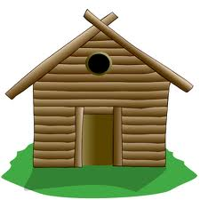
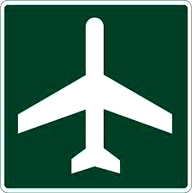
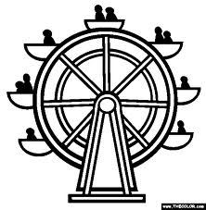
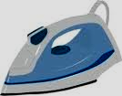

1)-------------------- 2)--------------------- 3)------------------ 4)------------------

D) Give the opposite of these adjectives.
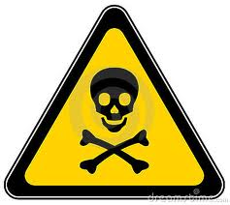
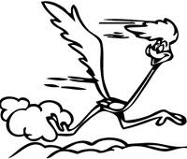
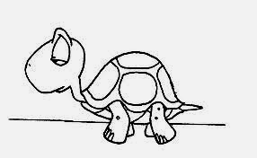


a)Dangerous # ----------------- b) fast # -----------------

V. Dictation.
A)Choose the correct letters. ______
4
h…t  ( a - d - r) | k…ee  ( m - n - v ) | An…ry  ( u - c - g ) | Sur…rised  ( c - p - k )

B)Complete the missing letters :

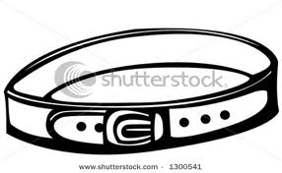 | 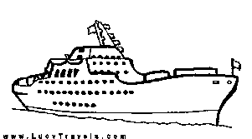 | 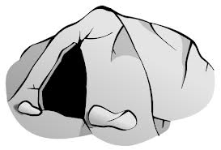 | 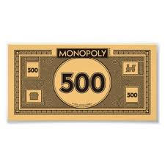
bel…. | s.…ip | ......,, ca….e | expe....sive

VI. Handwriting

Copy the following: _____
1- My friend is short and slim. She has got curly hair. 5

2-Al-Shallal theme park is the most popular in Jeddah.

End of questions
Best wishes
Tr. Basima Al-Lahem

