

The Final Exam for 1st Grade
Second Term
1435 - 1436 AH
Time: Two Hours

المملكة العربية السعودية
وزارة التربية والتعليم
الإدارة العامة للتربية والتعليم الطائف
مجمع عتاب بن اسيد
الصف الأول متوسط

 |  | Corrected by
30 | Thirty marks | Total marks

الاسم /Name: …………………………………………………………………………………………………….........…………………….

Q.1 - Read the following passage and answer the questions:

My name is Ali. My father's name is Bader. I’m 13 years old. I live in Tabuk with my family. My father is a doctor and my mother is a teacher . We live in a small house . It has three bedrooms , two living rooms , a kitchen and a bathroom. I love my family. I like English subject.

A- What is the father's name?
The father's name is …………………………………………………
B- How many bedrooms are there in the house?
…………………………………………………………………………………………
C- Put ( √ ) for true statement and ( X ) for false statement:
1- The father is a teacher. ( )
2- There are two living rooms in the house. ( )
3- Ali likes Math subject. ( )

Q.2 –

A – Complete and choose
1-What is your name ?
My name …………………………………….
2- How old are you ?
………………………………………………………..
3- Hello
a- fine . b-bye . c- Hello

B - Complete sentences with verb ‘Be’: ( am ) , ( is ) or ( are )
1-We ………………… Muslims . 2- I ……………..a student. 3- He ……………… a teacher.

Continued behind Page.
تابع خلف الصفحة

Q.3-

A - Match the suitable words under each picture:
( sandwich * watch * computer * mosque )

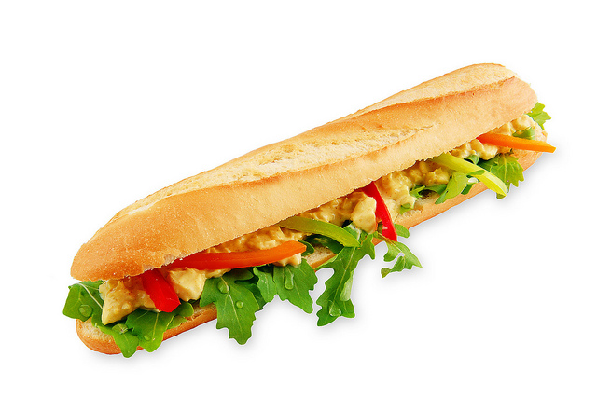
……………………
……………………
……………………
……………………

B - Match the suitable words with numbers under each picture:
Farmer
Math
Engineer
Policeman

4
1
2
3
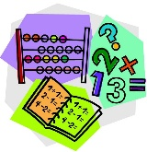
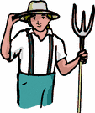
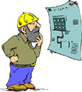

( ) ( ) ( ) ( )
C – complete comparative adjectives + er
1) old ………………………………….
2) small ………………………………….
3) cold ………………………………….
4) hot ………………………………….
5) play ………………………………….

Q.4-
A ) Write the missing letters : ( c , e , i , t )
ri__e t__a
ju__ce wa__er

B ) Copy the following

Please, pick up the box.

إنتهت الأسئلة

