Module 2

1- Vocabulary

1-Complete with the correct verb.

explore - go - buy - travel

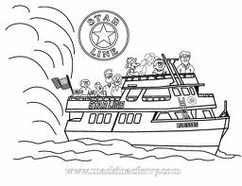
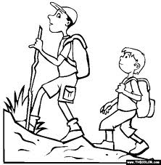
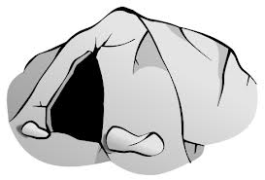
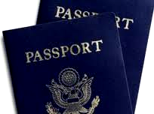

-------------abroad ----------on a cruise ------------ hiking ---------------- a cave
______________________________________________________________
2-write the words under the right pictures:

Ship - train – plane - tram - motorbike

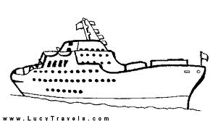
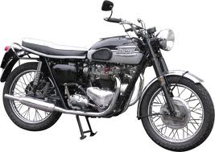
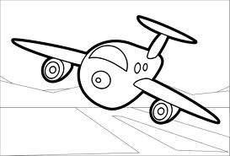
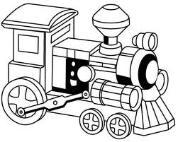

…………………. ………………………… ………………………. ………………………….

_____________________________________________

3-Write the opposite of these adjectives.
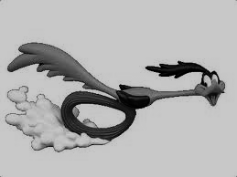

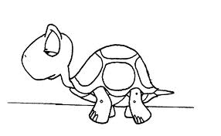
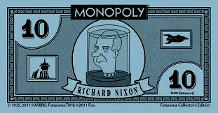
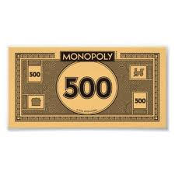
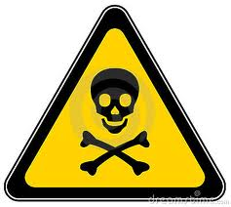

# # # #

a)Dangerous # ------------- b) fast # ------------- c) expensive # ---------------

4- Write the four cardinal directions.

---------------


------------- ---------------

---------------

5- Cross out the odd words.

1- interesting - amazing - weird - exciting
………………………………………………………………………………………

2- frightening - cool - awful - horrible

…………………………………………………………………………………………….

2- Grammar
I-Complete the sentences with the past simple form of the verbs in brackets.
1- Tony----------------(visit) Canada year ago and----------------------(buy)many souvenirs
,but he -------------------------(not take)lots of pictures.
2- They ------------------( be)good at maths last year.
3-I-----------------(be)tired yesterday so I didn't go to school.
_______________________________________________________________________________
2-Choose the correct answer
1 1 -Sam( can't - couldn't )speak French five years ago, but now he ( can - could ).
2 2 -A: (Do - Did )you see Afnan last week?
B: Yes, I ( did - do ).
A: ( Is - Was )she fine now?
B: No she isn't. She's very sick.
A: Did she ( go - went )to the hospital?
B: Yes, she did.
___________________________________________________
3-Complete with the appropriate adjectives or adverbs.
1 1 -The boys are happy. They play football-------------------------every weekend.
2-Malik is a ------------------- boy. He speaks politely.

4-Choose
1 -Motorbike is very ( dangerous - dangerously ). I can't drive it ( safe - safely ).
____________________________________________________________________________________

5-Fill the following spaces with the correct personal pronouns.
1- --------------- told -------------- about his voyage at the Nail when I visited him.
2- ---------------are so cold. Please make -------------- some coffee.
3-Look at --------------.She's beautiful.
4-Give -------------the souvenirs. He want ------------------.

6- Use the linking words( and /but /so /or because ) to join the sentences.
1 1 -I don't like basketball. I never play it.
------------------------------------------------------------------------------
2-Jim is a very slim boy . He's got curly hair.
------------------------------------------------------------------------------
3-Tom can drive a motorbike. He can't drive a car.
------------------------------------------------------------------------------
4- We arrived late. The Taxi was very slow.
------------------------------------------------------------------------------

