
Model 2
*Vocabulary:
1-Words and picture

1- Hoover.

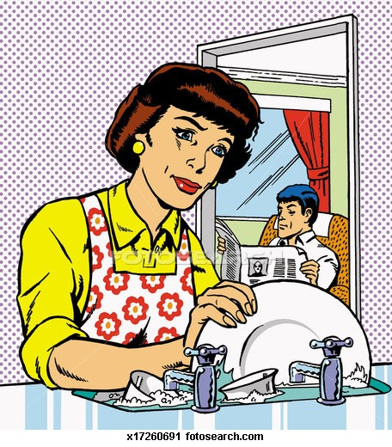
2- do washing up

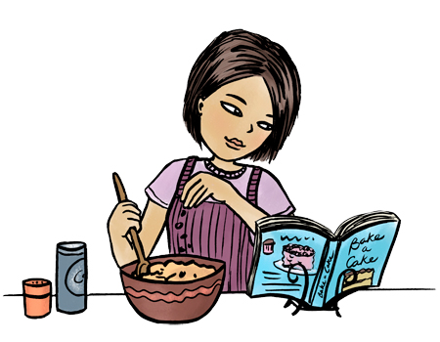
3-cook.

2-Jobs and places

1- doctor Hospital

2- receptionist Hotel

3- reporter. Newspaper office

*Grammar:
1-Present simple

S ( singular )+ v ( s )
ex: He wakes up early every day.

S ( plural ) + v (inventive)
ex: They play football every Friday.
Negative:
(singular) don’t+ v
( plural) doesn’t + v

2- Prepostions of time
in | at | on
-The morning.  -afternoon.  -evening. | -Time ( 9 o'clock-half past three)  -the weekend.  - night\midnight. | -Sunday,Monday,…etc  -Weekdays  -Friday evenings …etc

3- Present simple ( Question )

Singular plurals
-W question + does + s + v …? -W question+ do+ s + v …?
-Does + s + v……? - Do + s + v ……?

3-Would like\ like

Like\love\hate\cant stand + v (ing)  Ex: She love swimming. | Would like \want + to + v (inventive)  Ex: I would like to study French.

Exercises
*choose:
1-I ( study – studies – studying ) every evening .

2-Ali ( go – goes – going ) to school early .

3- (Do – Does) you wake up early ?.

4- She will visit her friend (on – in -at ) Sunday evening.

5-My work is ( in – on ) the morning .

6- I like ( swim swimming ).

7- He want to ( play – playing – played ) football today.

8-We ( don’t – doesn’t ) like black cars.

*DO as shown between brackets:

1- They go to school at 7 o'clock every day . (negative)
………………………………………………………………………………

2- I wakes up late at weekends. (correct)
……………………………………………………………………………………………

3- she cleans the house on Mondays. ( make question )
……………………………………………………………………………………………………..

*Vocabulary:

-Match the active with the picture:
1- Hoover

2- Do washing up

3- Cook

-Choose:

1- Ali is a doctor in the ( hotel – hospital – newspaper office ).

2- my brother is a ( receptionist – doctor – reporter ) in the Grand hotel .

T.Lammes Al-Omair

