
Model 3
*Vocabulary:
1-Spilling words
1- cousin. 5- nephew
2- stadium. 6- niece
3- daughter. 7- museum.
4- balcony . 8- wife.

2-photoes and items
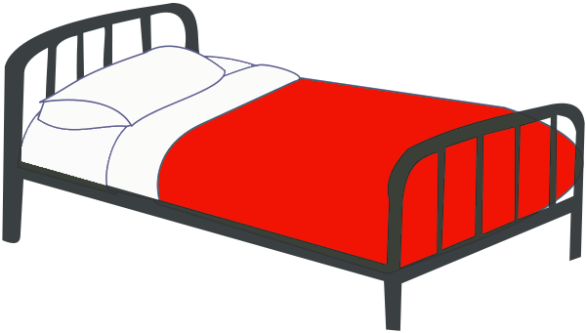
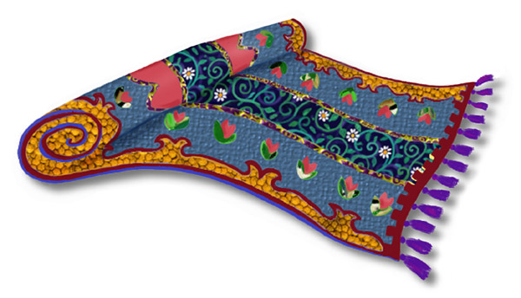
1- bed. 2- rug.
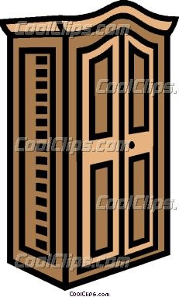

3- wardrobe. 4- curtains.
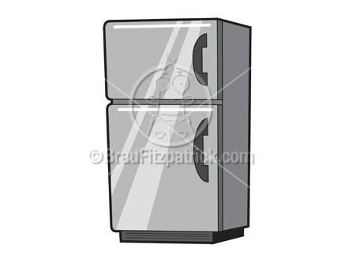
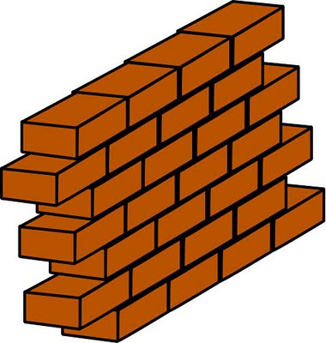
5- wall. 6- fridge

3- Prepositions of place

in on under in front

behind next to between

