10
U.1
U.2
2nd Grade_ 2nd Term (Quiz1) 5/5/1436H
Name/ …………………………………………………………………………………………………………….. Class/ …….
_____________________________________________________________________
Q1. Match the words and definitions:
diving |  | stop doing things/have a break | 1
rest |  | a sport where you go under water | 2
tower |  | now | 3
at the moment |  | a tall, thin building | 4
_____________________
Q2. Complete the table:
Question | Negative | In a sentence
……………………………. | no one | someone
anywhere | ……………………………. | somewhere
anything | nothing | …………………………..
**Q3. Match:
ship |  | sail on a ….. | 1.
car |  | ride a …. | 2.
bus |  | drive a …… | 3.
Q4. Choose the correct answer:
a. Ahmad is the ……………………… boy in the class. ( taller / tall / tallest )
b. Boeing 747s are ……………………….. than Airbus7380s. ( older / old / oldest )
c. Horses are …………………….. than elephants. ( fast / faster / fastest )
________________________
**Q5. Match with opposite
age |  | heavy | 1.
weight |  | tall | 2.
height |  | old | 3.
_________________________
elephant / plane / motorbike / horse
Q6. Put the correct word under each picture:
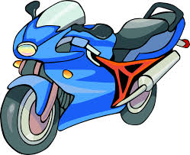
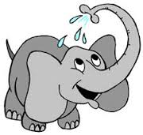

……………………… ……………………………
___________________________
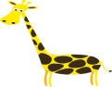
Q7. Complete the missing letters:
a) gira__fe

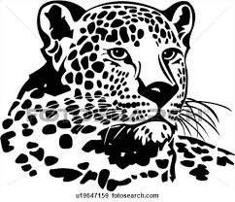
b) che__tah
___________________________
Q8.Answer these questions:
a) How old are you? ……………………………………………..……
b) How tall are you? ………………………………………………….
c) How heavy are you? ……………………………………………..
______________________________________________انتهت الأسئلة

10
U.3
U.4
2nd Grade_ 2st Term (Quiz2) 19/5/1436H
Name/ …………………………………………………………………………………………………………….. Class/ …….
_____________________________________________________________________
Q1. Read the following e-mail, then answer the questions below:
Dear Nina,
I read this information on the internet. Fred and you may be interested in it.
It's about writing competition for Book Club. The winners will get very good prizes. One of them is an ipad.
Best wishes,
Reema

A) Answer:
1. Who is the e-mail from? ………………………… 2. Who is the e-mail to? ………………………………
___________________
B) Who or what do the underlined words in the e-mail refer to?
1. I ………………………………. 2. you ……………………………….. 3. them …………………………………
______________________________________________________________
Q2. Choose the correct answer:
a) Are you afraid …………………… any animals? ( in / at / of )
b) What things are you good ……………………. ( in / at/ of )
c) Is your father interested …………………….. computers? ( in / at / of )
d) Will you answer phone? Yes, I …………………… ( did / do / will )
e) Pilgrims ……………………………. fly to Jeddah now. ( able to / could / can)
f) Pilgrims will ……………………………. to travel to Makkah by train soon. ( able to / could / can)
_______________________________
Q6. Complete the following sentence by using ( not only …… but also ):
a) Omar / speak / Arabic / English
……………………………………………………………………………………………………..………
__________________________
Q7. Put the correct word under each picture:
somke / race / ship / runner / fisherman / tent

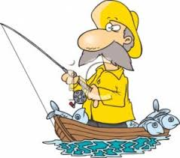
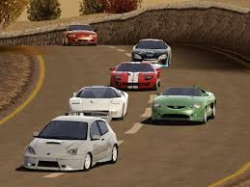
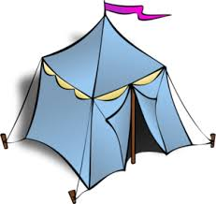
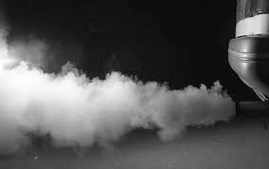
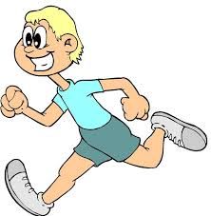

1. …………………….. 2. ………………………… 3. ……………………. 4. ………………………. 5. ……………………
________________________________
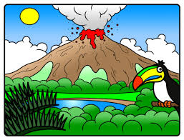
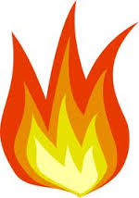
Q8. Complete the missing letters:
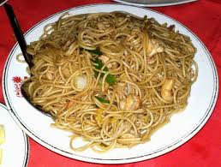
a) pa__ta b) fla__e c) vo__cano

___________________________

________
10

10
U.5
U.6

2nd Grade_ 2st Term (Quiz3) 1/7/1436H
Name/ …………………………………………………………………………………………………………….. Class/ …….
Q1. Read and write who or what do the words in bold refer to :
Helmets are important because they reduce head injuries to children when they cycle. Almost 80% of children under the age of 15 do not
wear them.

1. they …………………………………….. 2. them …………………………………
_________________
Q2.Write the correct words under each picture:
luggage / helmet / butcher / mechanic / skating / ice / water

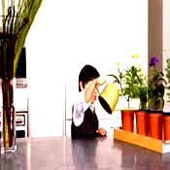
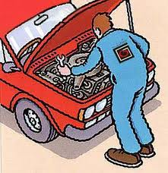

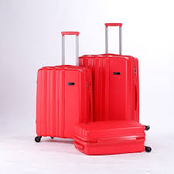
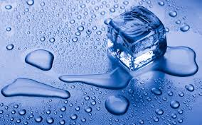
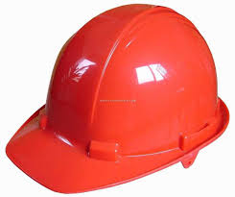
……………………… ………………………. …………………………. ……………………………. ………………………. …………………….
______________________________
Q3. (A) Do as shown between brackets:
1. When you leave the plane, take your luggage. ( Change to future )
……………………………………………………………………………..………………………….
2. When you put your luggage in the locker, you will turn off your phone.
( change to instruction)
…………………………………………………………………………………………………………….
________________________________
Q4. Match:
B |  | A
33% |  | half |  | 1
25% |  | a quarter |  | 2
%50 |  | three quarters |  | 2
 |  |  | 75%

_______________________
Q5. Choose the correct answer:
1. My lessons start ………………..9:00 ( in / at / on )
2. A large volcano erupted …………………. 1815. ( in / at / on )
3. What about …………………………….. TV. ( watch / watching / watches )
4. ………………………………. We play football? ( Shall / What about / Let's )
______________________
Q6. Complete the missing letters:
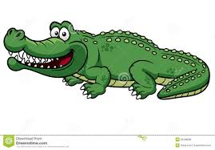
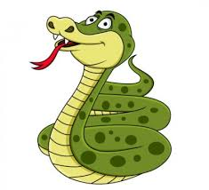
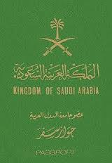
1. cro___odile 2. s__ake 3. Pass__ort

________
10

10
U.7
U.8

l
2nd Grade_ 2st Term (Quiz3) 17/7/1436H
Name/ …………………………………………………………………………………………………………….. Class/ …….
Q1.* Match the word with its definition : (Q1. /Q.4) Choose ONE of them
Giving money (alms) to hlp poor people. |  |  | Sawm |  | 1
Prying five times a day. |  |  | Hajj |  | 2
Fasting . |  |  | Zakat |  | 3
Saying the profession of faith |  |  | Salat |  | 4
 | Making a pilgrimage
___________________________
Q2. Choose the correct answer:
1. We …………………………. to pray five times a day. ( have / has )
wood
beautiful
door
2. She …………………………… to be polite to our teacher. ( have / has )
3. ……………………………. has to study hard. ( I / He )
___________________________
Q3. Look at the picture, then complete the sentences:
It is a German ………………………………… It is made of ………………………………..
It is ……………………………….
___________________________
Q4.* Q1. Match the word with its definition : (Q1. /Q.4) Choose ONE of them
say what may happen in future |  |  | a boot |  | 1
a strong heavy shoe. |  |  | a forecast |  | 2
a kind of bag, you carry it on your back |  |  | A hill |  | 3
a kind of light |  |  | a backpack |  | 4
 | High ground, small mountain
__________________________
Q5 Put : ( a ) ( an ) OR ( the )
1. I saw ………. man giving a boy …………….. ice cream . ……………… boy looked very sad.
_________________________
Q6.Answer by using (if):
1. What happen if you put ice in water? ( float )
……………………………………………………………………………………………………………
________________________
Q7.Write the correct words under each picture:
measure / sword / coin / matt / brush / float

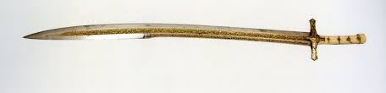
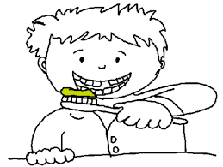
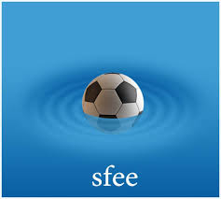
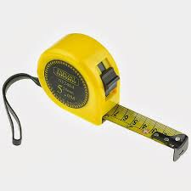
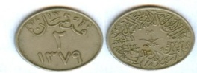

…………………………… …………………..… …………………………. ………………………….. ……………………………
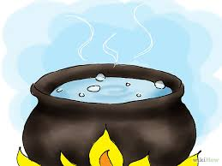
______________________
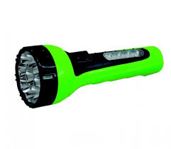
Q8. Complete the missing letters:
1.to__ch 2. __oil

NOTICE : (Q1. /Q.4) Choose ONE of them

