Name : …………………………… Class : ………………
How is your result ?
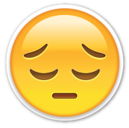  try harder |   well done
worksheet : ( )

Answer :
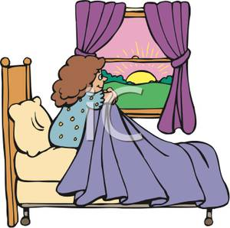
- What time do you get up ?
- I get up at __ __ am

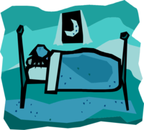
- What time do you go to bed ?
- I go to bed at __ __

