Name:……………………………………..…. Third Grade.

Comprehension:
3

Read the passage then answer the questions :
You will probably find it difficult to name any , because the past women were not allowed to patent their inventions ;until mid- 19th century anything a women owned or invented was legally her husband's . For this reason many female inventors throughout history forgotten or ignored .
All though hundreds of important women could be named, Bette Nesmith Graham one of them.
She invented liquid paper in an effort to cover her typing mistakes. She painted over them with white paint and watercolor brush. By the 1956, Graham invention became so much popularity.

A- Answer these questions :
- Were women allowed to patent their inventions ? ……………………………………………………………………………….
B- Choose the correct words :
Graham 's invention became popularity in ( 1967 / 1956 / 1856 ) .
Bette used ( red / blue / white ) paint to cover her mistakes .
C- Put ( √ ) or ( X ) :
Many female inventors named throughout history . ( )
until mid- 19th century what a women owned was legally her husband's . ( )
Information Question
2

A- Answer Questions:
1- Name three great inventions
a-…………………………………b-……………………

B- Choose the correct answer:

1- We start a blender by ( plug – plugging – plugged ) it in .

2- The CD has a ( square – round – oval ) .
3

Grammar
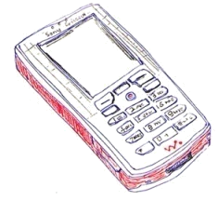
1- Rearrange the steps of sending a mobile massage by using sequence adverbs:
Then
Next
Finally
After that
First
…………………………….….., press " send " button
…………………………….….., write the massage
………………………………….., write the receiver number.
………………………………….., select "new massage" from the menu.

2- Do as shown between brackets :

1- * laptop ( ) *press ( )
(write the number of syllables)

1- You can start the car by turning the ignition key. (form a question)

………………………………………………………………………………………

Vocabulary
1

Write the correct word under each picture :
Plane , wheel chair, blender, vending machine, iron

 |  | 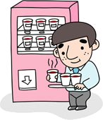 | 

1

Fill with the correct letters:
1-___nternet. 2-vacuum cleane____.

3-__ape recorder. 4- ___ell phone.





Miss: ………………….

