 | periods | class: 3rd |  | Lesson 1-2-3-4 | Unit:2

Unit Goals:

1\ To describe experiences , events and past activities
2\ To express and respond to feelings
3\ To express plans and intentions for the future
Pig Pictures ( great ideas):
1\Good Linguistic communication
2\ Appreciating team work and helping others
3\ Evaluating the importance of making plans for the future
Key words:
Achievement, ambition , dive , equal , ocean , pressure m submarine , surface , truck m astronaut , championship , cyclist , determined , give up , Olympic , biology , crash , hit , lightning , path , shoulder , storm , stream , survive
Learning Hook :
Tr. Greet Ss. She asks them about the weather .sheplays a game with Ss. To warm up then she asks then she shows them some pictures of famous characters and asks them .. who are these? What have they done ?do you know any thing from their inventions or achievements? . Tr. Introduces the title of the Unit
 | Basic Questions |  |  | Remaining Understanding
 | 1- who is your idol ? what are his \ her achievements?  2- who is James Cameron ? what was his achievement?  3- whatare your plans for the future?  4- who is JulianeKoepcke? What happened to her? |  |  | 1- We use the past tense to narrate stories  2- Ss. Will know basic facts about some characters ( date of birth ..etc)  3- Ss. Will know basic facts about the bottom of the sea
 | Key Knowledge and skills learners will gain after learning unit
 | Skills |  |  | Knowledge
 | 1 – Discussing the article in general ,S.W.B.A.T. answer some Qs. About the lay out individually . ( page 14)  2- Working in pairs , S.W.B.A.T. answer comprehension Qs. Correctly  . ( page 14)  3- Listening to the CD. , S.W.B.A.T. complete the chart quickly ( page 15)  4- Working in pairs , S.W.B.A.T. ask and answer Qs. About James Cameron fluently . ( page 15)  5- Revising the present perfect tens , S.W.B.A.T. form a complete sentence perfectly . (page 15) |  |  | Students will know :  1 – The new vocabulary  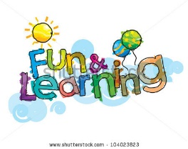  2 – The new structure  3- The new grammatical rules  4- The new information
6- After reading the conversation . S.W.B.A.T. decide whether some sentences are (T) or (F) and correct the false one without mistakes . (page16)  7- Listening to the CD. , S.W.B.A.T. narrate Salma's story in the correct order .(page 17 )  8- In a cooperative work ,S.W.B.A.T. write their plans for the future correctly (page 17)  9- After reading the story, S.W.B.A.T. answer comprehension Qs. Without mistakes ( page 18)  10- working in pairs , S.W.B.A.T. form sentences in past continuous correctly (page 19 )  11- Listening to the story , S.W.B.A.T. put the pictures in the correct order quickly (page19) |  |  | 
Stage2: The evidence and proofs of achieving the desired objectives (assessment )
Performance task
1- Tr. Divides the class into groups and each group will choose a character to talk about his her achievement
2- Ss. Will make a presentation in front of the class about the topic of the unit
Other evidence
1 – Role playing 6- Work sheets
2- Games 7- Group and pair work
3- Quiz
4-Assignment
5- K.W.L
Stage3: experience and learning plan
Teaching Experience |  |  | Learning Experience
1-Tr. Makes an open discussion then she asks the essential Qs. Which help Ss. To reach the great ideas and remaining understanding  2- Tr. Sets unit goals and discuss the performance tasks with Ss.  3- Tr. Asks Ss. To go through the book activities sequentially  4- - Tr. Explains how to use past continuous  5 Tr. Introduces the new words and provides pictures and other teaching aids to help Ss.  6- Tr. Uses CDs. And other technological devises to attract Ss. Attention  7- Tr. Evaluate the students performance by using a variety of activities  8- Tr. Encourages Ss. By using various methods |  |  | 1- students work as groups and in pairs  2- students ask and answer questions  3- Students form their own sentences using past continuous  4- students make a research and talk about different topics

Reflection: Did the Ss. Enjoyed the Unit ?
What was the most successful activity? Least successful ? why
Did the Ss. Learn something new?

Next Learning:
Ss. Will be asked to read the title of the new unit and gather some information about it
Homework:W. B page

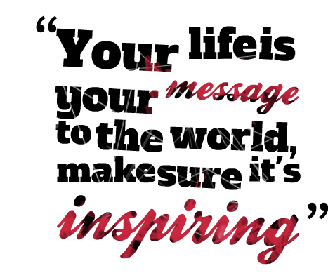
Achievements, Ambitions , Adventures

