1- Grammar:
A- Choose the correct word between brackets:
- Im not familiar……….this procedure ,could you please explain it?
- Of b) about c) with.
2-Vivid:
a)desire b)imagination c)range
3-small enterprises are considered to be the backbone of commerce in my country
a)not developed b)to have an undesired resultc)what gives strength to something.
4-I really don't………….. where we go for lunch jut as long as it's not too far
a)get b)mind c)end
5-The company has been so successful in recent months thatit seems highly ,………… that will have to make cutback
a)unlikely b) likely c) literate
6-a penny for your thoughts :
a)to be unusual but true b)series of thought that are connected c)something you say to ask someone what they are thinking about.

B. Do as shown between brackets:
1- yet in 2010,at the opening of a newly built sports academy in Qatar the seemingly………………….became possible .. [use possible]
2-if I………………..(to come) home earlier ,I……………….(to prepare) dinner ( conditional sentence 2)
3-'All the blue shoes are on sale' said the shop assistant (report)
The shop assistant said:……………………………………………………………………
4- if john had went to a good restaurant ,we would have had a better dinner (correct)
……………………………………………………….
5- I give up, I can't do any better than this (best)
………………………………………………………………………….
Elbow
liver
Ankle
Kidneys
Nostril
Lungs
Thigh
Intestines
waist
Match the words with their picture:

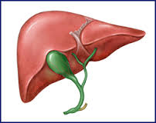
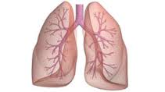
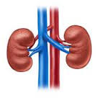

…………………………… ………………………………………… ……………………………………… ……………………………….

Month exam session 2 traveller 6 third year secondary
Name ______________________
1. Comprehension:
Read the passage and answer the questions:

Technology has changed our lives
People in Britain love technology. In a new survey of people in the country, researchers found:
• there are four computers in the average British household. • six out of ten people say their life is better with technology.The researchers also say that new technology has changed our world forever. Modern communication is a good example of this. For example, have you ever telephoned from a public telephone? Have you ever written a letter by hand? Many people haven’t done these things or they don’t do them anymore. In particular, the survey found that young people have never done the following activities because of modern technology:1 Telephoned a cinema for the times of the films.2 Booked a holiday at a travel agent.3 Used a public telephone. 4 Bought tickets for a concert over the phone.5 Printed photos.6 Bought a CD.
.
- Answer the following question:
- How many computers in the British household? ?
……………………………………………………………………………………………………………………………………………
Have people used public telephone?
……………………………………………………………………
- Put (T) for true statements and (F) for false ones :
- six out of nine people say their life is better with technology( )

