

30
Kingdom of Saudi Arabia
Ministry of Education
Tabuk Educational Zone
The 1st Intermediate school

The Final Exam
First term
First Session
1436-1437 H
Second grade

24

24

Final exam for 2nd Grade intermediate (-1436 / 37 A.H.)
Seat No: ……….................................................................. : s nameۥStudent

+

6
Reviewed by | Corrected by | Marks | Question’s No.
 |  |  | Question 1
 |  |  | Question 2
 |  |  | Question 3
 |  |  | Question 4
 |  |  | Question 5
________  24 |  |  | TOTAL

5

I- Composition
Q1: Complete this paragraph about your favourite place using the words in the box :
once
Eiffel Tower
previous summer
Paris in France
definitely
exciting

My favourite place is .............. It is in .................... I have been there ........... I went there in the ................. It's really .................! It's .............. my favourite place.

1
II- Comprehension

5
Q2: Read the following passage then, answer the questions:
Water is important for us because we need it for drinking and farming, but in the most of the kingdom , there is only about 10 centimeters of rain in a year .
There are five ways of increasing our water . First , we can use dams. Every winter , a lot of water runs through our valleys to the sea. We can stop this water by building high walls across the valleys. There are now several dams in the kingdom . The biggest is Wadi Jizan .
We can take water to dry areas by digging canals . Water runs along these canals and reaches land which has no water . This is called irrigation. We can also use the water in the sea . There is too much salt in it for drinking or for farming. But the government has factories for taking the salt out of sea water. In inland areas , we also get water by digging deep wells. These go down to underground lakes . Some of the water has been in these lakes for thousands of years
Lastly. We use water towers for storing water . These stop the water from evaporating . The most famous one is in Riyadh .
A- Answer the following questions:
1- Why is water important ?
...........................................................................................................................
2- How can we take water to dry areas ?
............................................................................................................................
3- Why do we use water towers ?
............................................................................................................................
B- Choose the right answer :
1. We use ( dams - wells ) to stop water in the valleys .
2. Factories take the salt of ( rain water - sea water ).
C- Put ( T  ) or ( F  ) :
1- There are four ways of increasing our water. ( )
2- The biggest dam in the kingdom is Wadi Jizan . ( )

2
III- Grammar

6
Q3: A- Choose the correct answers :
1- Whose is the parrot? It is ( Nina's - Ninas - Ninas' ).
2- You must drive very ( slow - slowly - slows ) in front of a school.
3- Yasser ( is not - didn't do - aren't ) much work on Wednesday.
4- Nina couldn't ( saw - see - seen ) Davey.
5- Her sister has ( fewer - less - many ) rice.
6- She has ( be - being - been ) there three times.
7- What are the shoes made ( on - of - to )?
8- Where is my bag? I can't find ( them - her - it ).
B - Do as shown between brackets :
1- Ahmad / play / football.
...................................................................
(Make a question with could )
2- I can ( swimming ).
..................................................................
( Correct the verb )

5
IV- Vocabulary

Q4: A- Give the opposites :
1- Put on # ....................... 2- come in # ....................
2- get up # ....................... 3- go to sleep # ...................

B- Put the right words under the right pictures:
captain – bee - bag – fire – window - coal - ambulance
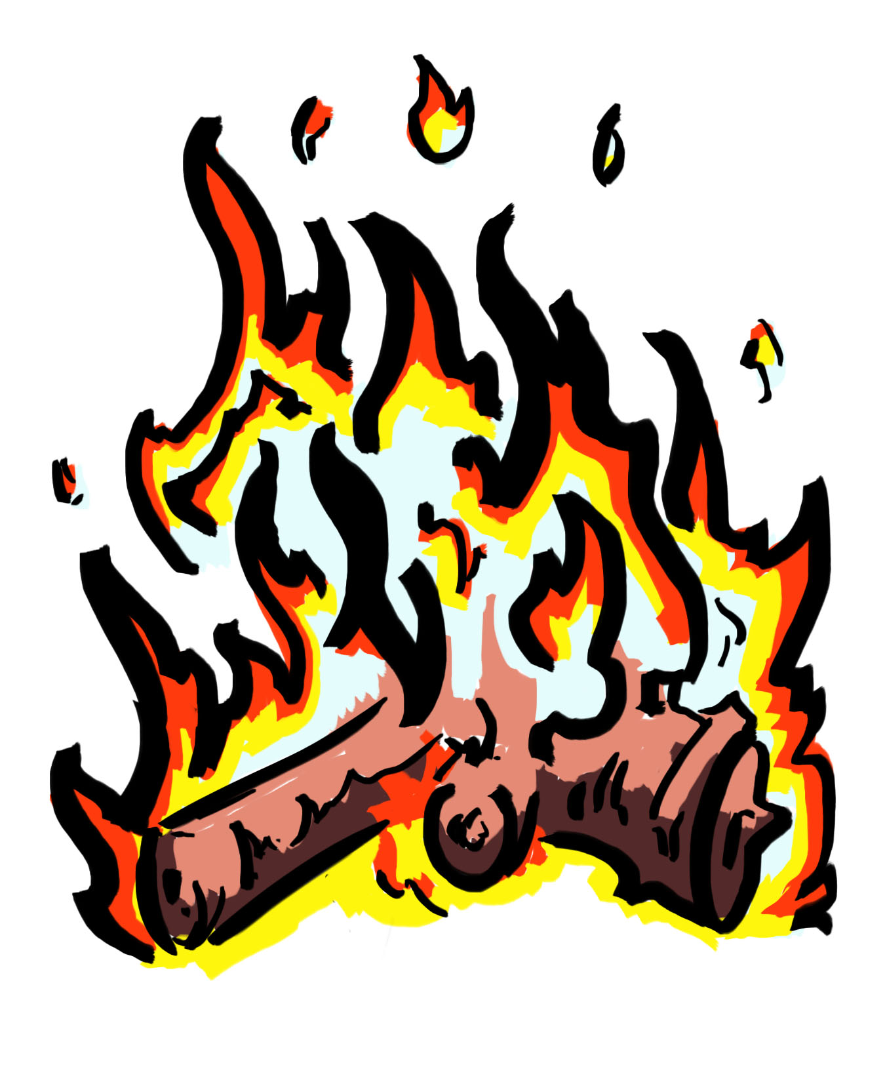
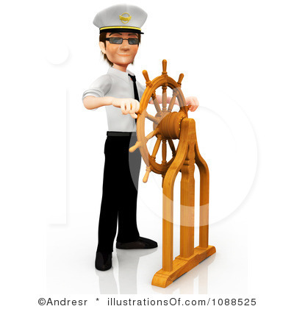
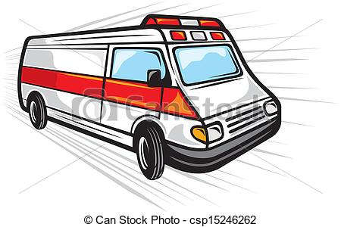
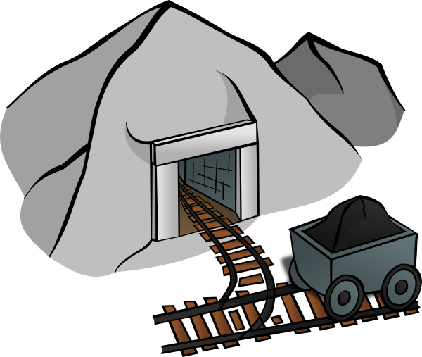
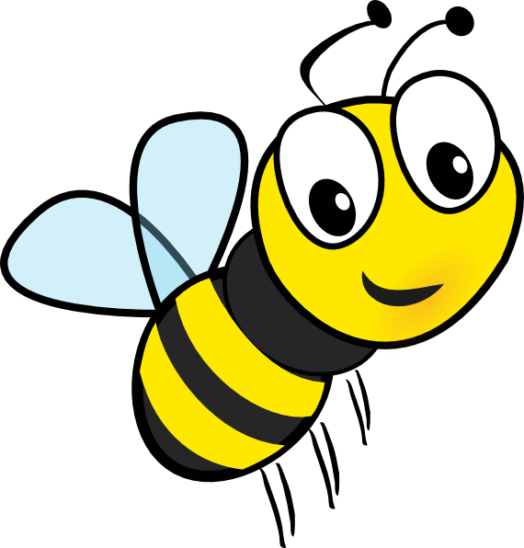


………...…… ................. …....…… .................. ………… ……………

3
V- Spelling

3

Q5: A- Reorder the letters :
1-nfuny ........... 2- xtie .........

B- Complete the missing litter :

 |  |  | 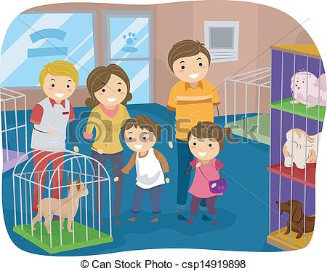
........war...... | .......paceshi...... | .......ake...... | ....et sho......
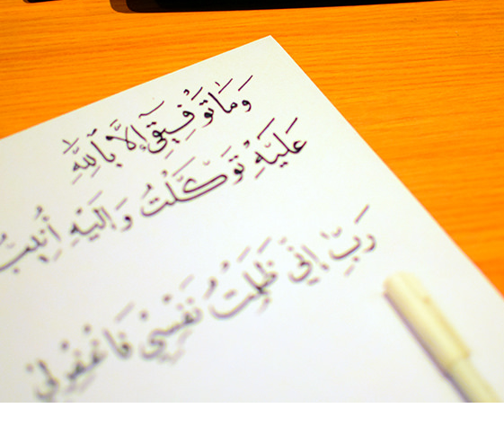

4

