
المملكة العربية السعودية العام الدراسي/ 1436 - 1437 هـ
وزارة التربية والتعليم الفصل الدراسي/ الأول
إدارة التربية والتعليم ب................... الصف/ الثالث المتوسط
مدرسة .................. المادة/ لغة إنجليزية

30

24

اسم الطالب باللغة العربية/ ............................................................................................ رقم الجلوس/ ........................

Reading Comprehension

5

Read the following passage then answer the questions.

Our village is near the River Ganges and tigers have always lived close by without disturbing anyone. But climate changed means they have to find new sources of food. As a result, a tiger killed a villager last year while he was collecting honey in the forest. However, tigers rarely come close to villages, so I couldn't believe my eyes when I saw one last month. It appeared suddenly as I was walking to my hut. I started running but it didn't chase me. I hid inside and held my breath. Then I heard it scratching at my door. I was terrified ! Fortunately, after a while, a group of villagers managed to scare the beast away.

A) Choose the right answers:
1- The village is close to ( Fall – River – Lake ) Ganges.
2- The tigers ( rarely – often – usually ) come close to villages.
3- A tiger killed a villager ( last week – last month – last year ).
4- The villager was collecting ( honey – flowers – fruits ) in the forest.
5- The beast suddenly appeared as the narrator was walking to his ( hut – farm – store ).

B) Put (T) or (F):
1- The story is about tigers and villagers. ( )
2- The narrator saw a tiger last month. ( )
3- Tigers are always disturbing anyone. ( )
4- Underlined word 'terrified' means happy. ( )
5- 'Climate changed' is to find new sources of food. ( )

Vocabulary

5

Choose the right word for each of the pictures.

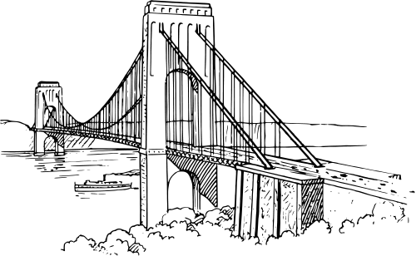

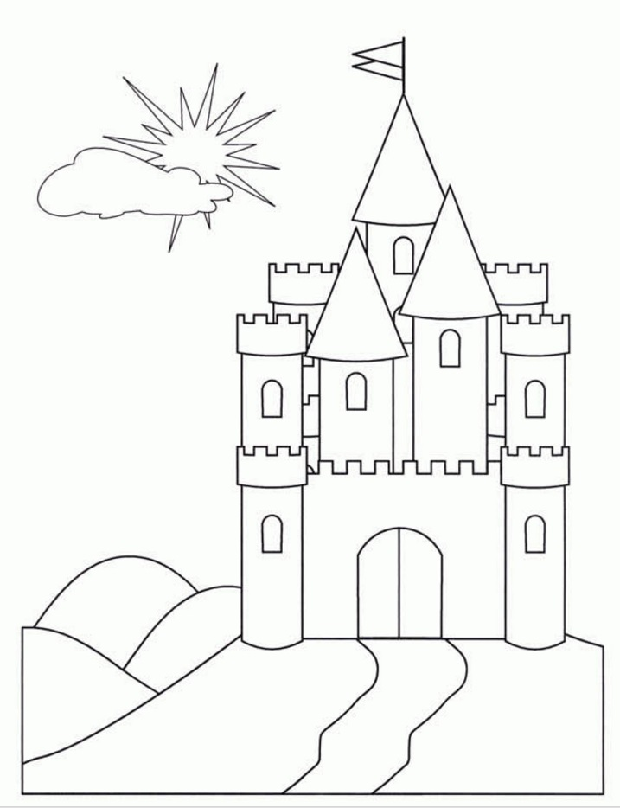


( ) ( ) ( ) ( ) ( )

1- Bridge 2- Statue 3- University 4- Palace 5- Mosque

5
Talk about your last trip
................................................................................................................................................................................. .......................................................................................................................................................................................................................................................................................................................................................................................... ..........................................................................................................................................................................................................................................................................................................................................................................................

Grammar

6

Choose the right word for each of the following.

1- They usually ( play – playing – played ) football outside the house.
2- Hassan can run ( fast – faster – fastest ) than Ameer.
3- Ahmed is the ( smart – smarter – smartest ) student in our school.
4- We are out of milk, ( anyone – someone – no one ) must go the supermarket.
5- Where ( do – does – did ) you go yesterday.
6- I ( use – used to – used to be ) meet my friends every day. But now I don't.
7- Khalid is the man ( which – who – where ) I met yesterday.
8- The city ( which – who – where ) he works is far away from here.
9- Fahad has ( go – went – gone ) to Hail with his family.
10- I've ( see – saw – seen ) many old friends lately.
11- Abdullah has been a teacher in this school ( for – since – in ) 2012.
12- She has studied French ( for – since – in ) 3 years.

Spelling

3

Fill in the blanks with the missing letters.



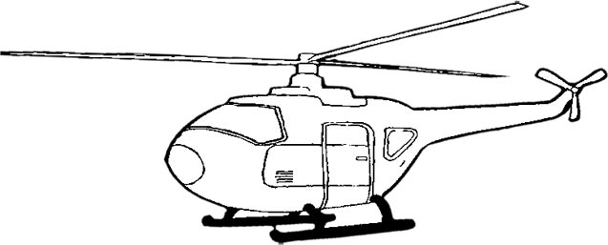

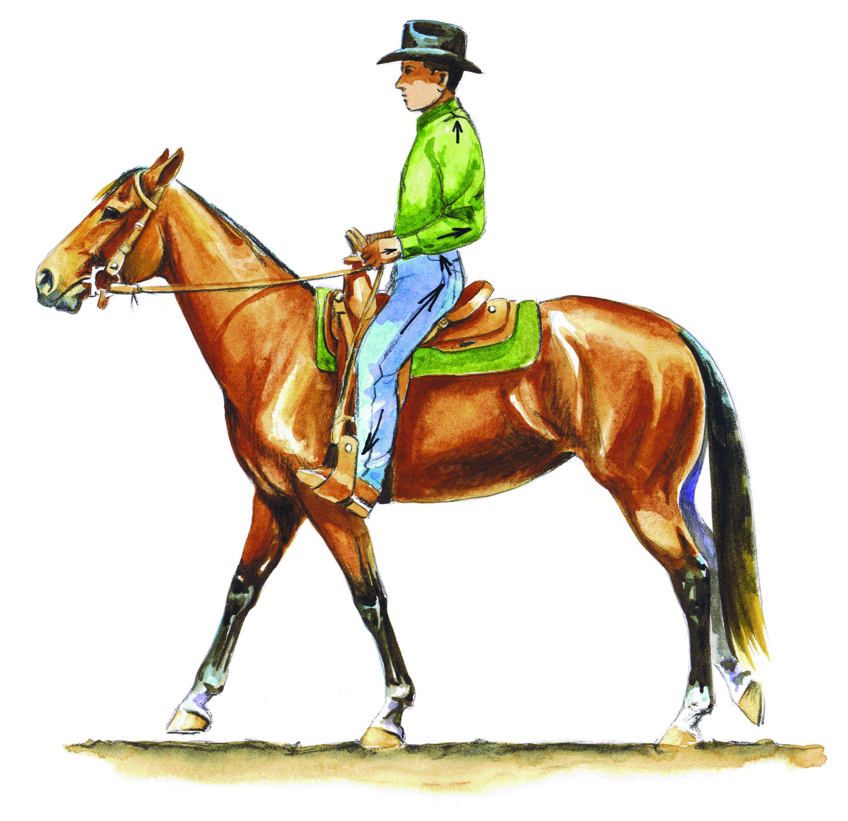

.....elicopter Poli.....e Hor.....e Swim.....ing Bi.....e Se.....ing

Good Luck

