Period | Class | Date
 |  | 22\4
 |  | 22\4
 |  | 23\4
 |  | 23\4

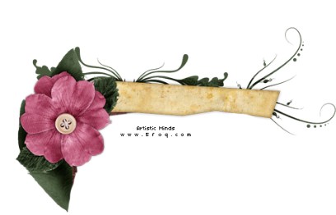
M1
Nice and Tasty

Title. 1d. Food Facts
Objectives:
1: reading the Questions and answers, Ss will be able to:
a: Explain the vocabulary.
b: Practice identifying specific information from
the Quiz.
2: reading the vocabularies in Ex2 , Ss will be able to
But each word in correct sentences carfully
3: understanding the Pronunciation of the letter "Gg" , Ss will be able to Identify the different sounds of the letter (G).

4: listening to the information , Ss will be able to match the information with picture correctly and make an order in the restaurant.

Evaluation :
p.14 Ex 1 .. a: read and match Questions with answers
b: read again then complete the sentences.

Ex.2 .. read the new words then put them in correct sentences ." Think, pair, share"

Ex.3 p. 15a: give words that have a "G" letter.
B: read the words then put them in correct Column

Ex.4 listen then match the information with pictures

Teaching Strategies:

Group work
Think, pair, share
Read now

Teaching skills:
Speaking
Writing
Reading
Listening

Teaching aids:

Book
Board
Real objects

Home work:

P82
Ex. a – b

" Teaching map "

Teacher's Name: Wafa'a Al-fraidi Principal's name:

