Kingdom of Saudi Arabia Final Exam Ministry of Education 2nd Intermediate grade Directorate of Education in …………. 2nd Term ………………... school Time: 1 Hour 30 Minutes

Question | 1 | 2 | 3 | 4 | 5 | 6 | Total
Degree
Corrector name |  |  |  | Signature |  |  | 30
Reviser name |  |  |  | Signature
Written degree
Name

- Read and answer:
Jeddah is called the bride of the red sea. It's located on the western coast of Saudi Arabia. The area is about 1,200 sq. km, and the population is more than two million. It's hot and humid during the year, but it gets better and less humid in winter. The city is famous for its long corniche and the huge fountain which rises about 200 meters from the sea.
- How long is the huge fountain in Jeddah?

5
……………………………………………………………………………………………

- Put ( T ) or ( F ):

- The weather in Jeddah is cold during the year. ( )
- Jeddah is in the western coast of Saudi Arabia. ( )
- The population is more than 2 million. ( )

- Complete the following blanks with words from the list below :

5
bridge – straight – know – maps – left

- Go …………………..… on this road.
- Turn ……………………… at the corner
- Do you ………………….….. that Ahmed is a doctor?
- There are different kinds of ……………………….…… like the world map and the city map.
- The station is under …………………………..

- Answer the following:

2

- Write a question to this answer.
…………………………………………………………………………………………?
Follow Up
- Mount Everest is 8,843 meters high.

- Choose :

10

- Ali is ………. English now. ( read – reads – reading )
- ………… speak loudly. ( Don't – Didn't – Doesn’t )
- ……….. straight on this road. ( Going – Goes – Go )
- Where ………….. you go yesterday? ( do – did – does )
- …………….. turn left. ( Didn't – Does – Don't )
- No ................. ( swims – swim – swimming )
- Did you study hard last night? No, I …………... ( did – do – didn't )
- Ali gave a book ………… me. ( at – to – in )
- Omar is ............... than Ali. ( tall – taller – tallest )
- ………… high is the mountain? ( How – Where – What )

- Write the correct word under each picture:

4
No Swimming - Sunstroke - Happy - Stop


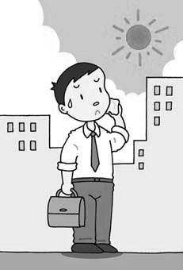
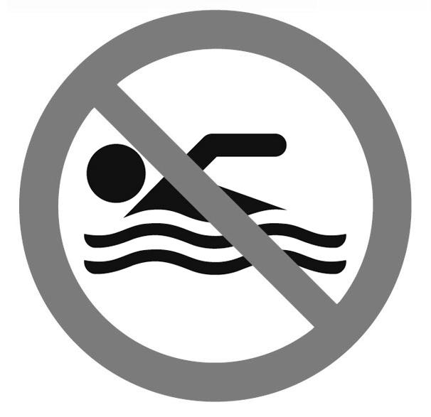


- Copy:

4

They are good students

You shouldn’t talk on the cell phone
Good Luck My Students

