المملكة العربية السعودية |  | مكتب التربية والتعليم
وزارة التربية و التعليم |  | متوسطة
الإدارة العامة للتربية و التعليم |  | متوسطة

اسئلة اختبار الفصل الدراسي الاول للعام الدراسي 1435/1436هـ
اسم الطالب |  | رقم الجلوس

المادة | لغة انجليزية | الصف | الثاني | الزمن | ساعتان | التاريخ | / /1436هـ
Q1) Choose the right answers :
1-Is Ahmed happy with his new job ?
d)yes he is not | c)No, you are not | b)yes, you are | a)yes, he is
2-What do you do in your free time?
d)My name is Ali | c)Good morning | b)I am healthy | a)play computer games
3-Where …………….he work ?
d)does | c)are | b)doing | a)do
4-How often do you go shopping ?
d)good | c)yes | b)usually | a)I am
5-Are you the new student ?
d)you are | c)he is not | b)he is | a)yes, I am
6-When do they exercise?
d)I can use computer | c)In the morning | b)I come from Qatar | a)I am Saudi
7-there …………… three accidents this week .
d)was | d)are | b)is | a)am
8-What …………..he look like ?
d)does | c)are | b)am | a)do
9-When were you born?
d)It is cold | c)Good afternoon | b)I was born in 1418 H | a)I was born in Jeddah
10-What would you like to be when you grow up?
d)thanks | c)good bye | b)hello | a) a doctor

 | 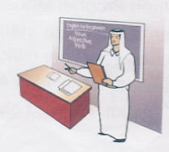 | 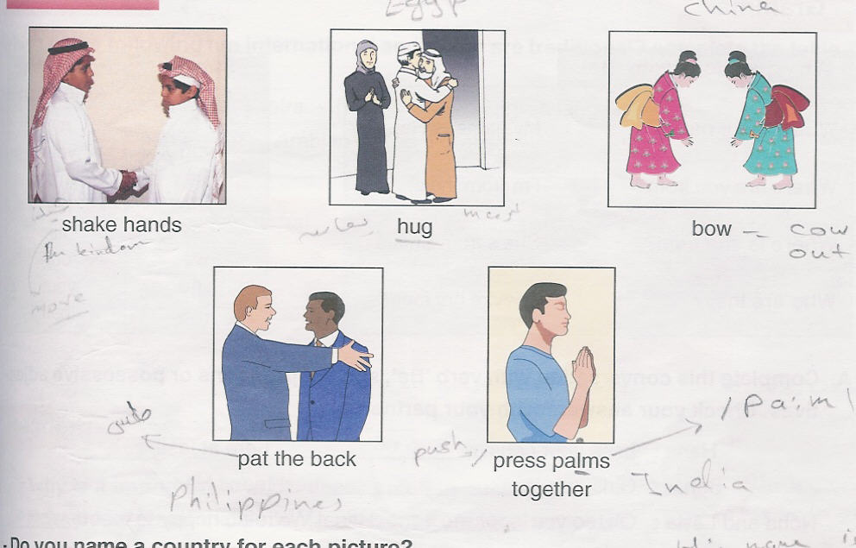  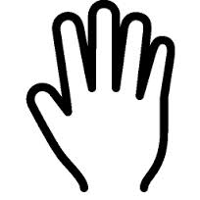 | 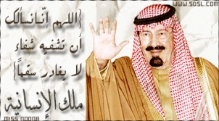
14:a)scared  b)happy  c)cry  d)sleepy | 13:a)sleepy  b)happy  c)scared  d)smile | 12:a)leg  b)eye  c)hand  d)hair | 11:a)King Fahad  b)King Faisal  c)King AbdulAziz  d)King Abdullah

 | 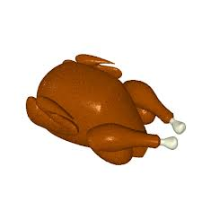 | 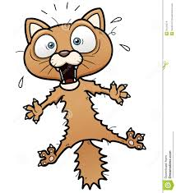
18:a)writer  b)director  c)singer  d)camera man | 17:a)chicken  b)salad  c)drink  d)juice | 16:a)happy  b)sleepy  c)scared  d) hungry | 15:a)artist  b)policeman  c)teacher  d)square

Choose the correct spelling:
d)droer | c)oderr | b)order | 19:a)oeder
d)airorpt | c)ariport | b)airpotr | 20:a)airport
d)nuesr | c)nesur | b)nruse | 21:a)nurse

22)Ali and Fahad…………watching TV.
d)does | c)are | b)is | a)am
23)there is not ………..juice .
d)any | c)some | b)good | a)many
24)He is……………now.
d)calls | c)calling | b)called | a)call
25)My ………….. is one of my body parts
d)half past six | c)book | b)car | a)hand
26)Are they watching TV?
d)No, they aren't | c)Yes, they do | b)No, he isn't | a)Yes, I am
27)I …………….hard last year.
d)studying | c)studied | b)studies | a)study
28)Where ………….. you go yesterday ?
d)Was | c)Does | b)Did | a)Do
29)It …………….a short story.
d)are | c)was | b)were | a)am
30)This is…………….book.
d)them | c)he | b)mine | a)my

Q2)Match:
a)salad | 1)how are you ? ( )
b)you should see the doctor | 2)what is your hobby ? ( )
c) I am fine thanks . | 3)My best food is ( )
d) playing computer games . | 4)I feel sick ( )
e) A-l-g-h-a-m-d-y | 5)how do you spell your last name ? ( )
Q3:After reading the passage, put ( T ) and ( F ):

My Family’s Jobs
My father and uncle have great jobs. My father is a photographer. He works in an advertising firm. He takes photos for different customers. He works Saturday to Wednesday. My uncle is a doctor. He works in the hospital. He helps sick people. And he works all the time.

1-The passage is about my family’s jobs. ( )

2-My father and Uncle have a bad job ( )

3-My father is a teacher . ( )

4-My father works in an advertising firm ( )

5-he takes photos for different customars . ( )

6-he works on Friday . ( )

7-My Uncle is a doctor . ( )

8-he works in the school . ( )

9- He helps sick people . ( )

10-he works all the time . ( )

