Kingdom of Saudi Arabia English Language

24

Ministry of Education 2nd Grade /Inter.
ministry for Girl's Education Second Term 1434/1435
Wadi-osial School Final Exam-2nd round.
Name:…………………………………………. Time: 2 hours
 | Total | VI | IV | III |  | II | I | Q. NO.  الفصل الثاني  الدور الأول
 | 24 | 3 | 5 | 6 |  | 5 | 5 | Mark N.
 | Twenty-four | Three | Five | six |  | Five | Five | Mark L.
 |  |  | Reviser |  |  |  |  | Corrector

5
1-Composition:
My name is.........., Iam...years old, my hoppy,my favorite food,my plan:Iam going to...
Write a few sentences about your self
and your plans for future? ?
................................................................................................
..................................................................................................
......................................................................................................
......................................................................................................
2- Comprehension:
My name is Ahmed Al - Ali. I'm Saudi. I'm from Jeddah. I'm 32 years old. I'm a teacher. I teach English. I go to school by car. I have a red car. It is big and new. My favourite sport is tennis.
Answer the questions:
1.) How old is Ahmed?
-------------------------------------------------------------.1

5
2.) Where is he from?
-------------------------------------------------------------.1
Choose the correct answer:
Ahmed Al - Ali is ------------------------------------.1
a) Saudi b) Yemeni c) Syrian
His favourite sport is ------------------------------.1
a) football b) tennis c) reading
Put ( ) or ( ) :
Ahmed's car is big and new. ( )½
Ahmed is a doctor . ( )½
3-Crammer:
A -Choose the right answer:

6
1) Iam going to(play-playing-plays)football next day.½
2)she(has-have)played yet.½
3) he ( cleaned – clean – cleaning ) her room two days ago . ½
4) they had this collection(since-for)1999 . ½

B-Do as shown brackets:
1-.He is going to write a story. ( Ask ) 1
...................................................................................................................................
2- I should go to school (Negative) 1
..................................................................................................................................
3-If you eating a lot, you get fat (Correct) 1
..................................................................................................................................
C- change the verbs in to the past:
1-go:............. ½ 2-do:................ ½

4 - Vocabulary:

5
A: Put the right word under each picture:
Laptop-deer- air plan -bat-mouse

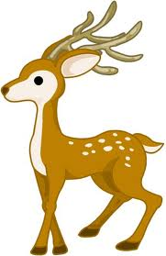
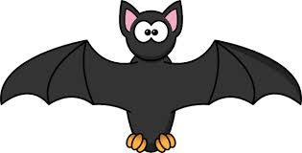


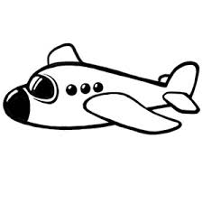
½ ½ ½ ½ ½

.............................. ......................... ........................... ................................ ...........................
B:
- Match ( a ) with ( b ):
a | b
- R  - 4  - CU  - @  - THX | …….. at. ½  ……. are. ½  ……. See you. ½  ……. Thanks. ½  ……. For ½

5- Orthograghy:

3
-Supply the missing letters:
1- m...use.¼ 2-....eyboard.¼ 3-f...x¼. 4-happ...¼

5-fo..est. ¼ 6-b...t. ¼ 7-came... ¼ 8-foot..all.¼

9-pas..a ¼ 10-fi..h ¼ 11-san..wich. ¼ 12-l...mon ¼

Best wishes
Yours teacher:Khuzama

