
Unit ( 1 ) Lesson ( 3 )
سبحان الله و بحمده سبحان الله العظيم
My Name …………………………………………………………………………………………………………………………………………..

Q 1: Write the correct word under each picture :

( scince - math - history - French language – art – sport - Arabic – Geography – P.E. – technology – scared )

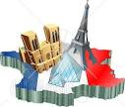

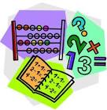


……….. ……… ………. ………. ………

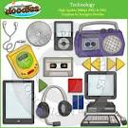
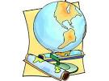
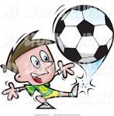
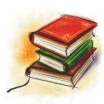


……… ….…… …..…… …….... …….. ……….

Q 2: Complete :
1- ………………..…… is The subject which study maps and countries .
2-Foot ball and basket ball are examples of ……………………..
3- You can draw pictures in …………………. Subject .
4- He is very ……………… from the dog .

Q3: Give the abbreviation :
1- Kingdom of Saudi Arabia .
2- Physical Education . ………………….


Mrs: Lamia

