Name:……………………………………………… class:4/ …
Q1/ choose:
1-How are you?
a-Fine thank you b- Good morning

2- Good morning:
a- Good morning b – Hello

Q2/ write the correct word:
Bike / kite / Box / Bed
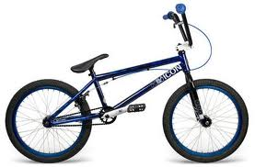
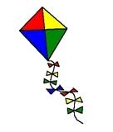
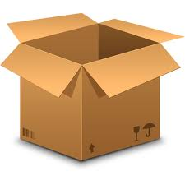
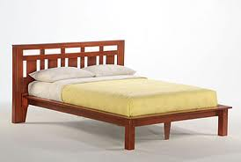

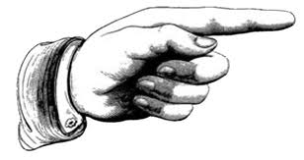
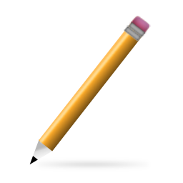
Q3 /Answer:
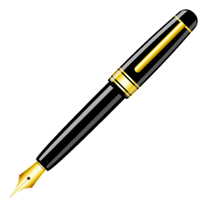
- ( That – This ) is a pencile.
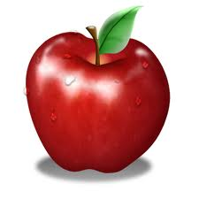
- (That – This ) is a pen.
- (Those – These ) are apples

