

1- Comprehension
Read the passage then answer the questions below :
1001 Inventions is an international scientific and cultural organization. It publishes books and holds exhibitions to help people around the world discover the contributions of Muslims to science and culture. For example, major exhibitions were held in Dhahran in Saudi Arabia in 2012 and in Washington, USA, in 2013.
A - Answer these questions:
1- What is 1001 Inventions ?
...............................................................................................................
2- What else does 1001 Inventions do?
...............................................................................................................
B - Choose the correct answers :
1- The major exhibition were held in ( Dhahran - Riyadh ) in Saudi Arabia .
2- The major exhibition were held in Washington, USA, in
( 2013 - 2000 ).
**************************************************
2-Grammar:
A- Do as shown between brackets:
1- Hind cleaned the room .
.......................................................................................................................
2- Ahmed closed the window .
.......................................................................................................................
( Make the sentences in the past simple passive tense )
3- Help your friends .
.................................................................................................
4- Don’t play with fire .
.................................................................................................
( Report the sentences )
B- Choose the right answer :
1- Cheques ( was - were ) used by Arab businessmen.
2- Vaccinations were ( discovered - discover ) in Turkey.
3- letters were ( write - written ) by Mona.
4- He told me ( don't - not to ) waste my time .
5- He told me ( for - to ) help the old man .
6- Could you answer the quiz? ( He asked - He told ) me to answer the quiz.
7- I have been watching TV ( since - for ) 3 hours .
8- ( she - They ) has been studying since 5 p.m.
9- We ( have - has ) been playing football for 1 hour.
10- Ali has been working here (since – for ) 12 years .
11- Ali has been sleeping ( since - for ) 2 o’clock . He is asleep now.

****************************************************
3-Vocabulary :
A-Mach the words with the correct pictures :
( laboratory - lens - mathematics - soap )
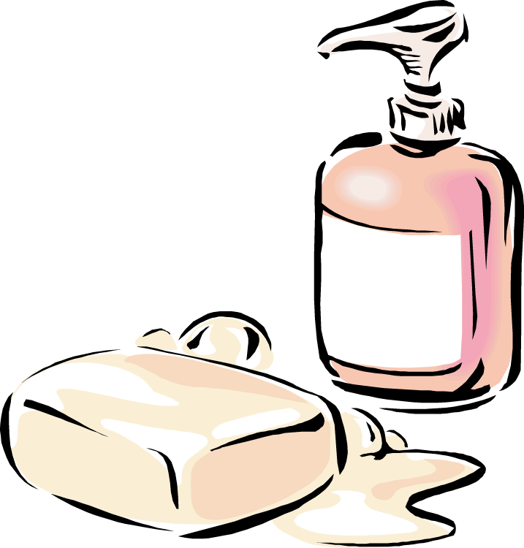
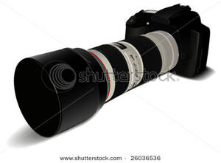

.................................................................................................

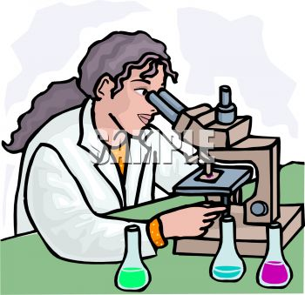

.................................................................................................
**********************************************************

4- Spelling:
A - Choose the correct letters:
1-........accination ( a – l – v ) 2- pro......ise( m – k – j )
3- puz.......le, ( y - z – d ) 4-e.............ay ( W –T - B )
5-.......octorate ( e – d – a ) 6-.............oil ( r – s – n )

