1- Comprehension
Read the passage then answer the questions below :
eBay is an internet company . It was established in 1995 by Pierre Omidyar. eBay was first based in San Jose in the USA. Now it has similar businesses in 30 other countries.
eBay is a market where people can buy and sell things. However, there is no physical market. Buying and selling takes places online on the company's website.
Items are advertised on the website by sellers. Buyers choose goods and the buyer who offers most money is sold the item by the seller. eBay gets its money from fees paid by sellers on its website.
eBay is a successful business and website. Millions of people in different countries use it to buy and sell new and second-hand goods.
A - Answer these questions:
1- Is eBay an internet company ?
................................................................................................................................
2- When eBay was established ?
.................................................................................................................................
B - Choose the correct answers :
1- eBay was first based in ( San Jose - New York ) in the USA.
2- eBay gets its money from fees paid by ( buyers - sellers ) on its website.
***********************************************************************
2-Grammar:
A- Do as shown between brackets:
1- I think I'm going to the sea this weekend.
..........................................................................................................
( Possibility )
2- Ahmad has exam tomorrow.
..........................................................................................................
( Certainty )
B- Choose the right answer :
1- The car ( is - are ) washed by Ali.
2-The dinner is ( cook - cooked ) by Hind.
3- The football ( was -were ) played by Ali and Ahmad.
4- The cheques were ( used - use ) by Arab businessmen.
***********************************************************
3-Vocabulary :
A-Mach the words with the correct pictures :

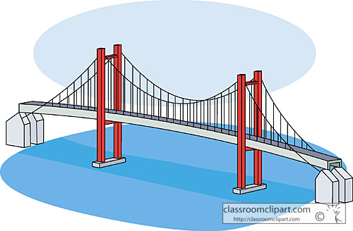
( causeway - remote - label )
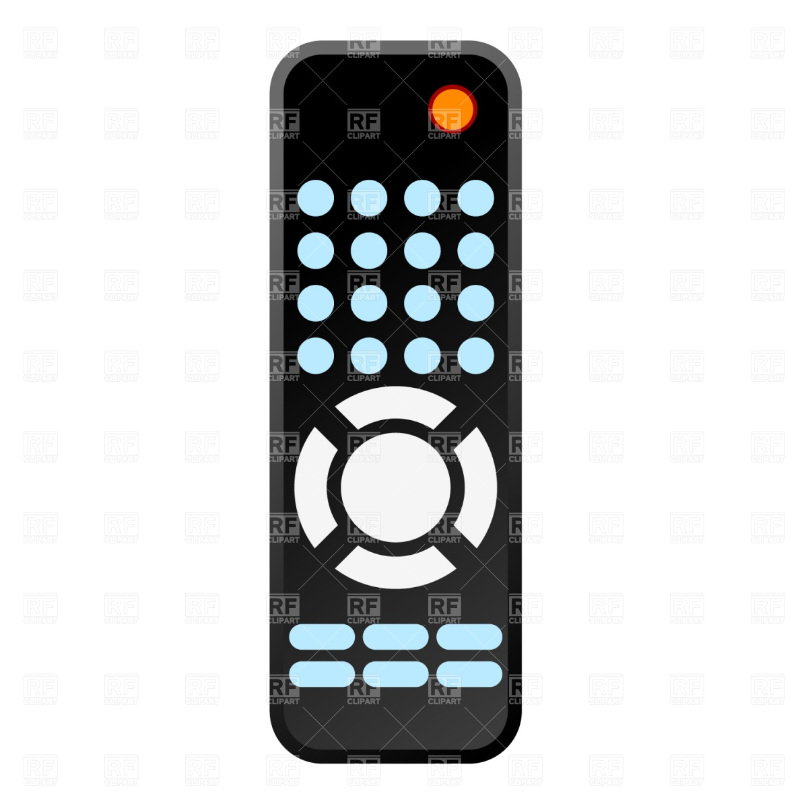

..........................................................................................................

4- Spelling:
A - Choose the correct letters:
1- adverti..........e ( e – s – k ) 2- goo.........s ( n – f – d )
3-apart.........ent ( f - s – m ) 4-.........onclusion ( W –c - z )
5-authori......y ( k – s – t ) 6-re-equi.......( p – m – a )

