
المملكة العربية السعودية المادة : اللغة الانجليزية
وزارة التعليم التاريخ : / 5 / 1436هـ
المتوسطة الـ الوحدة : الأولى

First exam of Module 1: "Nice and Tasty" for first intermediate grade
Name: ………………………………………………………………..…….. Class: …………

_______
10

Q1: Comprehension:
Read the following passage then answer the questions:
Hello, my name’s Alfredo and I am 13 years old. I am from Italy. For breakfast, I usually have biscuits with milk. I love biscuits. For lunch, my mum makes some pasta and a fish or meat dish. Of course, we always have salad. For dinner, I often have meatballs with tomato sauce. At the weekend, I sometimes have an omelette with vegetables and cheese or meet.

- Answer this question:-

2

1. What is the boy's name? 2- How old is he ?
---------------------------------------------------------------------------
B) Choose the right answers:-
1-Alfredo is from ( Italy ,Franc , Morocco ) .
2- For lunch he has (soup , salad , meatballs ).

C) Put ( √ ) or ( X ) :
1- For dinner he has an omelette. ( )
2- He does not love biscuits. ( )

2

________________________________________
Q2: Vocabulary :
onion - steak - rice – pancake - pasta
A.Write the correct word under their picture:
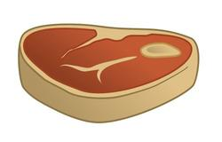
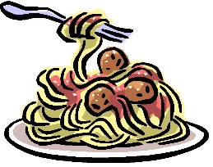

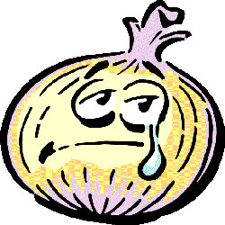

…………………………
…………………………
…………………………
…………………………

2

B. Complete with the words in the box:
slice
sauce
glasses
order
delicious

1. let's ……………. pizza from the restaurant.
2. I like eating pasta. It is ………………………
3. Can I have ………………. of bread, please?
4. Drink 8 ……………… of water. It is good for you.

_________________________________________________
Q3: Grammar:

2

Choose the correct word:
1: ( How much – How many – How old ) eggs do you eat in a week?
2: There are ( a – an – some – any ) tomatoes on the table.
3: Is there ( some – any – a ) mushroom in the fridge?
4: I like eating some ( cherry – cherries ) with breakfast.
_________________________________
Q3: Dictation:

2

Full in with the correct letter:
d_tes _heese
Pe_per yog_urt
_ilkshake chi_s
Doughnu_ lamb ke_ab
_______________________________
معلمة المادة
أ/ وفــاء الفــريدي

