Revision for unit : 9
1- Comprehension
Read the passage then answer the questions below :
Ibn al-Hytham was a famous Arabic scientist. He was born in Basra in today's Iraq. People call him 'the father of optics' because he studied the science of optics and wrote many books about it. His major work was Kitab al-Manazir (Book of Optics). For more than 500 years it was the most important book about optics. One of Ibn al-Hytham's inventions was the camera obscura. It was a kind of ancient camera. Rays of light from a bright object outside pass through a small hole. They make an image of the object on the white wall in the room.
A - Answer these questions:-
1- Where were ibn Al Haytham born?
He was born in Basra in today's Iraq.
2- Was Ibn al-Hytham a famous Arabic scientist?
Yes, he was.
B - Choose the correct answer:
1- One of Ibn al-Hytham's inventions was the ( mobile - camera obscura).
2- For more than ( 500 - 10 ) years Kitab al-Manazir was the most important book about optics.
C - Tick ( √ ) or ( X ):-
1- People call Ibn al-Hytham 'the father of optics' ( √ )
2- His major work was Kitab al-Manazir ( × )
*****************************************
2-Grammar:
A - Do as shown between brackets :
1- Your phone looks very smart.
Would you like to try my phone?
( Make an offer )
1

B - Choose the right answer:
1- Where is my bag? I can't find ( them - her - it ).
2- Can you speak louder, please? I can't hear ( you -me - us ).
3- Would you like to ( driving - drive - drove ) the car.
4- Nina had ( a - an - some ) food on the plane.
5- Did the stewardess have ( any - some - much ) apple juice?
****************************************************************************3-Vocabulary :
A-Mach the words with the correct pictures :
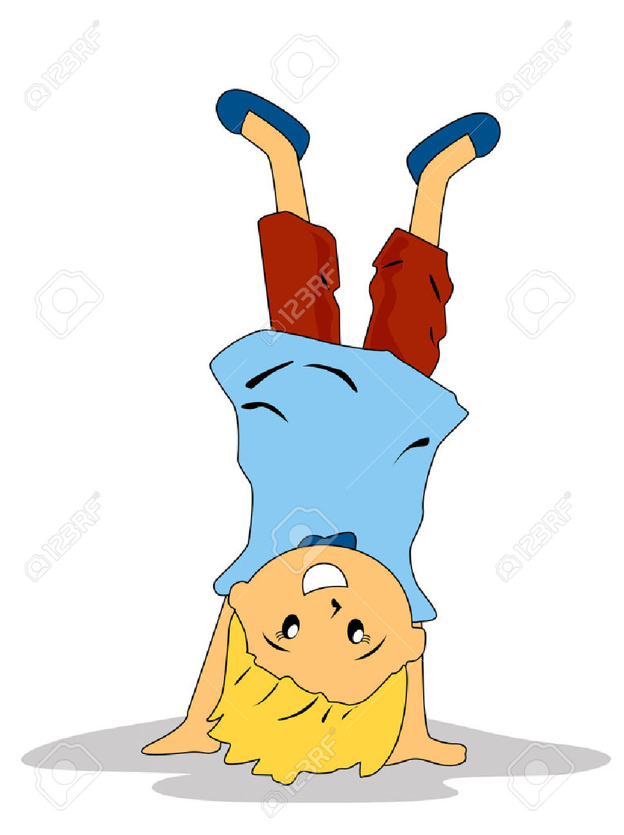
( web page - stewardess -bumpy - upside down )
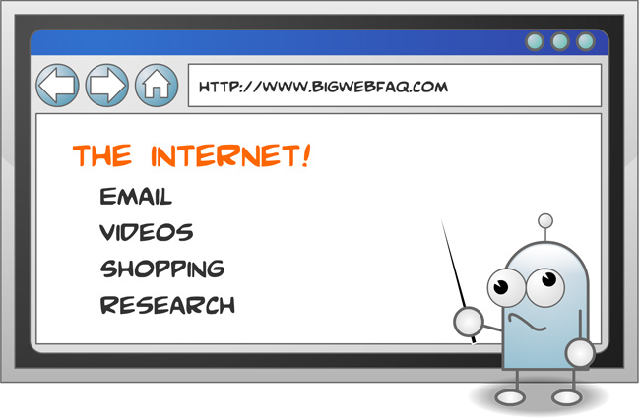



upside down.......................... .................................... web page

stewardess....................................... ........................... bumpy
2
****************************************************************************
4- Spelling:
A - Choose the correct letters:
1- ........id ( f – t – k ) 2- in.........ent ( j – v – q )
3- i........age ( m - x – b ) 4- jet la....... ( e – g - s )
*********************************************************************
3
Done by: Ba7er

