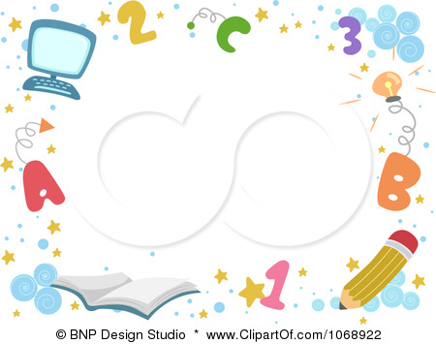


6th week | 5th week | 4th week | 3rd week | 2nd week | 1st week
25-29 /12 | 18-22 /12 | 26/11 – 1/12 | 19-23 /11 | 12-16 / 11 | 5 -9 /11
2-Right now  Chant  Smart kid | Revision-Project  Smart- phonics | Lets play-phonics  Story time  17 National Day | Smart kids  Our world | My friends-My family  1-Every day  A chant Ameer’s day | Introduction-Hello  Smart friends
12th week | 11th week | 10th week | 9th week | 8th week | 7th week
8-12/2 | 1-5/2 | 23-27/1 | 16-20 /1 | 9-13 /1 | 2 -6 /1
Story time-Revision  Smart-phonics | Our world  Let’s play-phonics | 3-Mynew House  Chant  Smart kid | Story time-Revision  Smart-phonics | Our world  Let’s play-phonics | Hajj Holiday
18th week | 17th week | 16th week | 15th week | 14th week | 13th week
20-24/3 | 13-17/3 | 6-10/3 | 29/2-3/3 | 22-26/2 | 15-19/2
------------- | The End of the Final assessment period | Revision | Story time-Revision  Smart-phonics | Our world  Let’s play-phonics | 4- Food,please  Chant  Smart kid
مدير المدرسة :

التوقيع :

مشرف المادة : أ .

معلم المادة :

التوقيع :

التوقيع :

