Name : …………………………… Class : ………………
How is your result ?
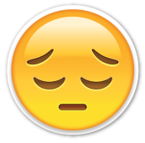  try harder |   well done
worksheet : ( )

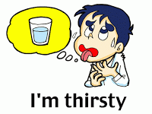
Answer :
- What's the matter ?
- I'm _________ .
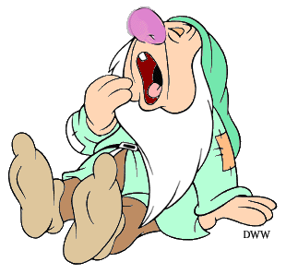
- What's the matter ?
- I'm _________ .
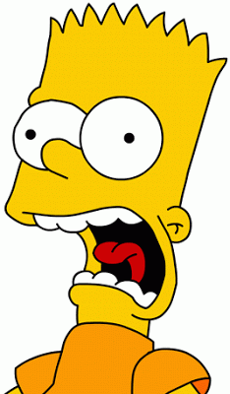
- What's the matter ?
- I'm _________ .

