Name:..............................................................Class:.......................
1- Comprehension
Read the passage then answer the questions below :
Natural gas. like coal and oil, is an important source of energy. Like coal and oil, natural gas is located in rocks underground. It formed there in the distant past.
To look for natural gas, a hole is drilled deep into rocks underground. If natural gas is discovered, it is pumped to the surface. There it is cleaned
and then it is separated into its different parts. This is because natural gas has a number of different gases in it.
A lot of natural gas is produced in Saudi Arabia. Some natural gas is used here to produce electricity, to produce fresh water from sea water and for cooking. Some natural gas is compressed into a liquid when its pressure is increased. It is then transported through pipes or in ships to other countries.
A - Answer these questions:
1- Where can you find natural gas ?
...............................................................................................................
B - Who, What or where do the words in bold refer to ?
1- Paragraph A: It ....................................................
2- Paragraph C: here................................................
C - Choose the correct answers :
1- A lot of natural gas is produced in ( Jordan - Saudi Arabia - Egypt ).
2- Natural gas transported through pipes or in ( cars - trains - ships).
**********************************************************
2-Grammar:
A- Do as shown between brackets :
1- The case is damaged . It happened at the airport .
........................................................................................................................................
( make apologies )
B- Choose the correct answers :
1- She has been ( read - reads - reading ) a novel .
2- If I were you, I ( had told - would tell ) my father the truth.
3- After ( see - saw - seeing ) the movie . He went to bed .
4- The car ( are cleaned - is cleaned ) by Ali all the time .
***************************************************************************
3-Vocabulary :
A-Mach the words with the correct pictures :
( carpet - damage - drill - sledge - supporter )



............................................................................................................................
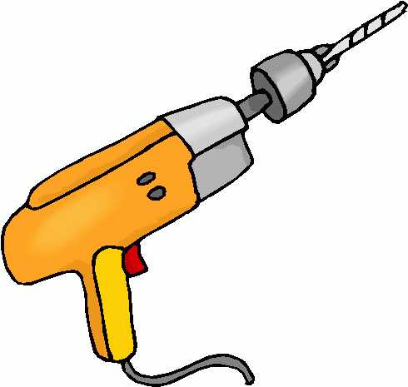
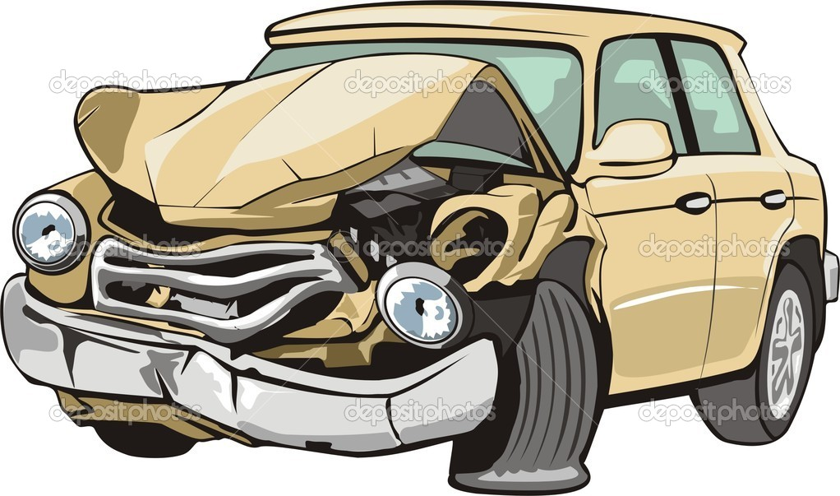

.................................................................................................................................
****************************************************************************
4- Spelling:
A - Choose the correct letters:
1- humanitaria.......... ( n – k – b ) 2- ni…… ( l – d – r )
4- .......rap ( n – t - m 3-……roduct. ( n – p - m )
5- expe......ition ( g - m – d ) 6- since.......e. ( l – p – r )
7- compres…. ( s – k – l ) 8-geo…ogist. ( l – p – s )

