Name : …………………………… Class : ………………
How is your result ?
  try harder |   well done
worksheet : ( )

Match :
Clap – clock – lock – cap
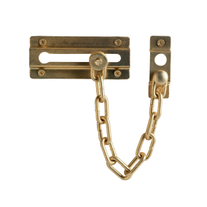 | 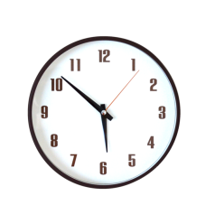 |  | 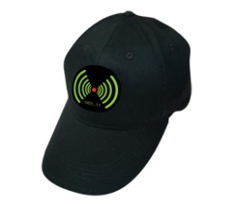
……………………………… | ……………………………… | ……………………………… | ………………………………

Choose :
- A is the ( first – third ) letter
- D is the ( fourth - second ) letter
- H is the ( sixth - eighth ) letter

