المملكة العربية السعودية |  | مكتب التربية والتعليم بوسط جده
وزارة التربية و التعليم
الإدارة العامة للتربية و التعليم

اسئلة اختبار الفصل الدراسي الاول للعام الدراسي 1436/1437هـ
اسم الطالب |  | رقم الجلوس

المادة | لغة انجليزية | الصف | الثاني | الزمن | ساعتان | التاريخ | / /1437هـ
Q1)Choose the right answers :

1) She …………… tennis every day .
d) played | c) playing | b) plays | a) play
2) my father wakes up …………… 5:00 in the morning .
d) under | c) in | b) on | a) at
3) I …………… not drink tea .
d) are | c) is | b) does | a) do
4) I …………… football.
d) plays | c) playing | b) play always | a) always play
5) Is he drawing ?
d) It is | c) No, he is not | b) No, he is | a) yes, he is not
6) I am …………… football .
d) played | c) playing | b) plays | a) play
7) I want to …………… a book .
d) readed | c) reading | b) reads | a) read
8) did she …………… ?
d) cooking | c) cooks | b) cooked | a) cook
9) He drives……………
d) cares | c) carefully | b) care | a) careful
10) He is a …………… student .
d) no | c) worse | b) good | a) well
11) The teacher is talking , listen to …………… .
d) him | c) is | b) you | a) I
12) I was …………… Tv , when my father came .
d) watched | c) watches | b) watch | a) watching
13) When something isn't cheap . It is …………… .
d) expensive | c) bad | b) dangerous | a) fast
14) How old are you ?
d) no I am not | c) yes I am | b) I am 14 | a) I am fine
15) …………… you watch TV last night ?
d) did | c) am | b) is | a) does
16) Where is the captain ? …………… is over there
d) Them | c) They | b) He | a) I
17) I will meet you …………… Saturday .
d) to | c) in | b) at | a) on
18) The missing letter in Saud_ is
d) i | c) x | b) m | a) r
19) The missing letter in schoo_ is
d) e | c) l | b) j | a) z
20) The missing letter in co_puter is
d) i | c) r | b) m | a) z
21) The missing letter in sho_t is
d) z | c) r | b) x | a) q
22) The missing letter in _ elt is
d) r | c) b | b) k | a) c

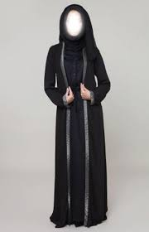  26) | 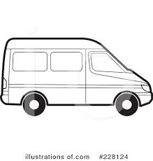  25) | 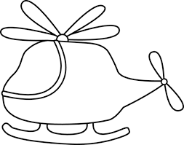  24) |   23)
- skirt  - Abaya  - boot  - thobe | - van  - airplane  - rocket  - spaceship | - car  - train  - helicopter  - ship | - pyjamas  - hat  - watch  - shoes
30)  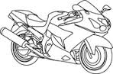 | 29)   | 28)   |   27)
- car  - truck  - tram  - motorbike | - friendly  - unfriendly  - writing  - cooking | - happy  - shy  - angry  - smile | - active  - lazy  - sleep  - read

(2)- Match

a) information from the net. | 1) surf ( )
b) the net | 2) read ( )
c) out with friends. | 3) play ( )
d) the book. | 4) download ( )
e) golf | 5) go ( )

Q2)Match:

Q3:After reading the passage, put ( T ) and ( F ):

King Fahd International stadium is in the eastern part of Riyadh, Saudi Arabia. It's a football stadium, but athletics events also take place there. The stadium opened in 1987 and it can hold about 70,000 people. It is a beautiful stadium with a very clever roof. It keeps almost all the sports fans out of the sun. It is actually the largest stadium cover in the world. King Fahd International Stadium is the home of the Saudi Arabian National Football Team and they play all their important matches there.

Put [ F ] or [ T ]
( ) | 1-king Fahd international stadium is in the eastern part of Jeddah
( ) | 2- It's a basketball stadium.
( ) | 3- The stadium opened in 1978.
( ) | 4- It keeps almost all the sports fans out of the sun.
( ) | 5- It's a beautiful stadium with a very clever roof.
Good luck

