
Kingdom of Saudi Arabia English Language . Flying High 1
___
40
Ministry of Education 1st Grade Secondary
1st Term Exam First Session
Date : /3/1437 Time: Three Hours
أسئـــلة اختبار مادة اللغة الانجليزية للصف الأول الثانوي–الفصل الدراسي الأول - الدور الأول لعام 1436-1437 هــ
Name /________________________________________________. Seat No.(___) Class ( )

1-Comprehention

_______ 12
Read the following passage carefully , then answer the questions below:

Mark Hanson was born in Walla Walla , Washington, in the USA but when he was young , his family moved and he grew up in Northern California .His father worked as an academic and the house was full of books. As a young boy, Mark liked the same things that many children do. He played sports , rode around neighbourhood , on his bike and wanted to go to university. But when he was 17 years old , he was involved in a car accident. This event was no change his life forever. After the accident in 1977,he converted to the Islamic faith and changed his name to Hamza Yusuf . Then he decided he would study Islam and he spent four years in the UAE and Saudi Arabia.
A)Answer the following questions:
1- What is the title of the passage?.................................................................................................
2-Where was Mark Hanson born?.....................................................................................................
3-Did he grew up in America?...........................................................................................................
B)Put [ T ] or [ F ]
1- Mark Hanson worked as academic. [ ]
2- Mark Hanson become a Muslim. [ ]
C)Choose the right word:
1-/His/ in line :2 refers to [ Mark - Mark's father - Mark's son ]
2- "The word /converted / in line:5 means : [ studied - lived - changed ]
D) complete:
1- When he was 17 years old , ……………………………………………………………………………………………..
3- He spent ……………………………………in the United Arab Emirates and Saudi Arabia.

P .T . O

_______ 10
2—Vocabulary
A) Match the words with their meanings :
1-Career | [ ] | calorie
2-relaxation | [ ] | A place that makes coins.
3-fossil fuels | [ ] | origin
4-versus | [ ] | Against
5-note | [ ] | rest
6-source | [ ] | work
7-luricate | [ ] | Petrol
8-mint | [ ] | Paper money
9-Energy is measured by | [ ] | Make something easy.

B) Choose the right word:
1- Celebration and festivals represent people's [ culture - thoughts - necessity ]
2-flu and cold are [ illnesses - symptoms - treatment]
3-I don’t want to [ gain - waste - lose ] weight so I'm going to eat less.
4-The energy from the sun is called [ solar - nuclear - geothermal ]
5- I think that's a very [ interested - interesting - interest ] idea.

c) Complete:
1-Lung cancer and cardiovascular problems are caused by ………………………………………………………………
2-"There are many ways to SAVE money " the word "SAVE" means: ……………………………………………..

d) Write the word under the correct picture.
Skydiving - prescription - fast food - cookery - gardening

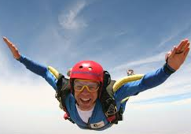
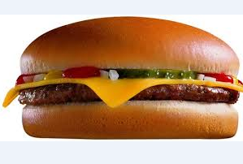
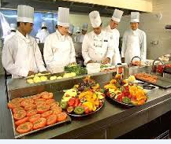
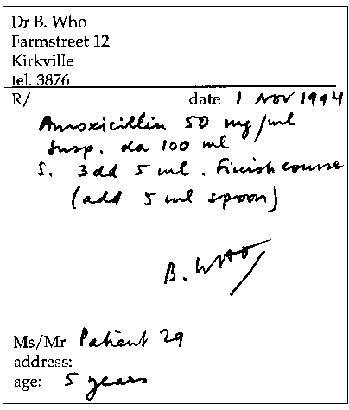

……………………………. …………………………… ……………………………… …………………………………………..
_______________________________________________________________________________________________
P .T . O

3—Grammar:

_______ 10
A) Do as shown between brackets :
1-They played around a lot . …………………………………………………………….……………………..[ USE : used to
2-Taif is beautiful than Jeddah but Abha is the beautiful city in KSA. [CORRECT ]
……………………………………………………………………………………………………………………………………………………………………………..
3-If I earn a lot of money, I …………………………………………………………………………………………[Complete]
4- I'm going to university. I’ll get a good job . …………………………………………………………………………………..………………………………………………..[ Join with: because
5- We (live) in Canada for six months. ……………………………………………………………….……..[ Correct the verb]
6-They cooked the beef on the grill. …………………………………………………………………………..[Change into passive ]
B) Choose the right answer :
1- The school isn’t big [ too - too much - enough ]
2-My brother is good student and I am [so - too - neither ]
3-I'm looking forward to [ visit – visited - visiting ] you.
4-I wish I [ speak - spoke - speaking ]
___________________________________________________________________________
4-Writing:

_______ 8
Write a short paragraph about yourself.( Using the following information )
Name and age - Date and place of birth - secondary school - level - your hobbies - future -
Like and dislike .

…………………………………………………………………………………………………………………………………………………………………………………………………………………………………………………………………………………………………………………………………………………………………………………………………………………………………………………………………………………………………………………………………………………………………………………………………………………………………………………………………………………………………………………………………………………………………………………………………………………………………………………………………………………………………………………………………………………………………………………………………………………………………………………………………………………………………………………………………………………………………………………………………………………………………………………………………………………………………………………………………………………………………………………………………………………………………………………………………………………………………………………………………………………………………………………………………………………………………………………………………………………………………………………………………………………………………………………………………………………………………………………………………………………………………………………………………………………………………………………………………………………………
With my Best Wishes
دعــائــــــي للجميـــــــــع بالنــجاح والـتفــوق,,,,

