Kingdom of Saudi Arabia English Language

Ministry of Education 2n^{d} Grade /Inter.
ministry for Girl's Education Second Term 1434/1435
Al-Barza School Final Exam-first round.

Name:…………………………………………. Time: 2 hours

Question | الدرجـة رقما | الدرجـة كتابة | المصححة | المراجعة | المدققة
Composition
Reading Comprehension
Grammar
Vocabulary
Orthography (Spilling)
Total

5

Q1: Composition:

Write a paragraph about your pet use the guide words [ my pet - name – colored - eyes – lovely – live - going out – like – feed eat – having time ]
-----------------------------------------------------------------------------------------------------------------------------------------------------------------------------------------------------------------------------------------------------------------------------------------------------------------------------------------------------------------------------------------------------------------------------------------------------------------------------------------------------------------------------------------------------------------------------------------------------------------------------------------------------------------------------------------------------------------------------------------------------------------------------------------------------------------------------------------------------------------------------------------------------------------------------------------------------------------------------------------------------------------------------------------------------------------------------------------------------------------------------------------------------------------------------------------------------------------------------------------------------------------------------------------------------------------------------------------------------------------------------------------------------------------------------------------------------------------------------------------------------------------------------------------------------------------------------------------------------------------------------------------------------------------------------------------------------------------------------------------------------------------------------------------------------------------------------------------------------------------------------------------------------------------------------------------------------------------------------------------------------------------------------------------------------------------------------------------------------------------------------------------------------------------------------------------------------------------------------------------------------------------------------------------------------------------------------------------------------------------------------------------------------------------------------------------------------------------------------------------------------------------------------------------------------------------------------------------------------------------------------------------------------------------------------------------------------------------------------------------------------------------------------------------------------------
( 1 )
Q2: Reading Comprehension:
Read the following passage and answer the question :
A-Answer the question :
Ahmed is very happy because his family can go on holiday this year . Last year they couldn’t go anywhere because they were very busy . This year they decide to go to Egypt because there are many interesting things there . His mum can’t go by plane because she is scared of flying . They will have to go by the car .they will visit the pyramids and the Sphinx .They will go to the sea in Alexandria .

5

- 1- why Ahmed is very happy ?
- ………………………………………………………..
- 2- where do they decide to go this year ?
- ……………………………………………..
B- complete :
3- His mum can’t go by plane because ………………………………………………………………. .

C : put ( T) or ( F)

1- they will go to the sea in Alexandria . ( )
2- They will have to go by the train.( )

6
Q3:Grammar :
A-Choose the correct answer :

1- They are ( going to - will ) destroy that rubbish tomorrow .
2- I can’t stand (waste – wasting ) food.

3-You ( mustn’t - couldn’t ) climb up the tree , it is very dangerous .
4- English is [ speak – spoken – spoke ] all over the world .
5- The news [ are – were – is ] shown on this channel every day .
6- My cousin was [ chosen – chose – choose ] for a scholarship last year.
7- These stamps [ was – is – were ] collected three years ago .
8-The bus is (too-enough) slow, so let's get the metro.
-2-

B-Do as shown in brackets :
5- I am going to paint the door tomorrow . (will)
……………………………………………………………………………..
6-She tidied the room yesterday . ( passive)
………………………………………………………………………………

5
Q4:Vocabulary:

A -Match the words with their correct picture:
1-sleepy 2- fan 3-newspaper
4- tyre 5-motorbike 6- stones



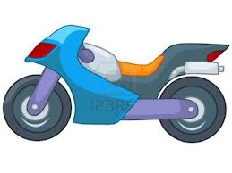
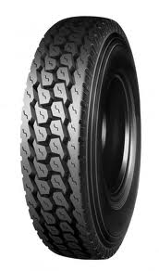
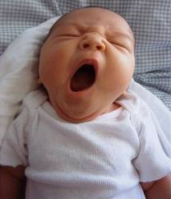
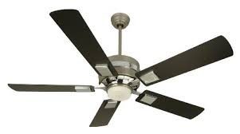

B-Choose the correct word to complete the sentences :
Shopping centre - inventor- trap- breathe

1-The …………makes new things .
2-This ………. Will help us to catch the mouse .
3-Let’s go to the ……………….. I need a new hat.
4-Humans …………..in oxygen .
-3-
Q5:Orthography (Spilling):

3
A-Write the missing litters:
1-screa---. 2- fl---wer.
3-ro –-- d. 4-lo---k.
5-tou---. 6-bu---h

My best wishes
Mrs. Rania

4--

