
Kingdom of Saudi Arabia
المادة .............................................. التاريخ ............................................ الفترة ............................................. الصف ...........................................
General Administration for Girls’ at Aseer
The Elementary school >>>>>>>>>>>>>>

الإسم/........................................................ . الصف/.ســـــادس ( )

الرقم | اسم المهارة | الدرجة | اتقنت | لم تتقن | المستوى
13 | comprehend the meaning of the following English punctuation and capitalization (period, comma, colon, semicolon ,question mark)

1 ) Choose the correct answer :
a: ……hat is your name ?
( ) W ( ) w
b: Is she a nurse ……
( ) ? ( ) .
c: Yes ……… she is .

الرقم | اسم المهارة | الدرجة | اتقنت | لم تتقن | المستوى
22 | do controlled writing exercises such as supplying missing letters or words
2 ) Fill in the missing letters : -



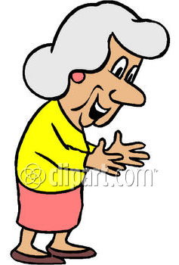

key__oard mo__itor unc……e gran…..mother

3) – Write the correct word under each picture : -
grandfather – printer – mouse – aunt

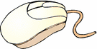

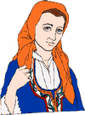

__________

الرقم | اسم المهارة | الدرجة | اتقنت | لم تتقن | المستوى
22 | recognize ordinal numbers: 1st, 2nd, 3rd, etc.
4 ) Put in order:
Sixth / fourth / second / third / first / fifth

1 |  | 4
2 |  | 5
3 |  | 6

الرقم | اسم المهارة | الدرجة | اتقنت | لم تتقن | المستوى
27 | use verb to be (am, is are) in affirmative, negative and interrogative statements
5 ) Choose the correct answer :

1- Are they sisters ?
Yes , they ( am / are / is )
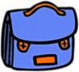
2- ( Is / Are / Am ) it a bag ?
Yes , it is

3- Are you a doctor ?
No , I ( are / am / is ) not .

الرقم | اسم المهارة | الدرجة | اتقنت | لم تتقن | المستوى
27 | recognize possessive adjectives:  my, our, your, his, her, its, their

6 ) Choose the correct answer :
a: This is ( my – She ) pencil .


b: This is ( her – my ) ice cream



c: This is ( his - I ) car .
Good Luck
جروح صامتة

