Kingdom of Saudi Arabia. | بسم الله الرحمن الرحيم | 2nd Year Intermediate.
Ministry of Education. | 30 | Term : 2nd term.
General administration for |  | Final exam.
Education in Asir. |  | Year : 1430 – 1431 H.
.......... Intermediate School.  نموذج إجابة | 30 | Time : 2 hours.

اســــم الـطـــالب : ...........................................................................................................................................................................................................................................................
رقــم الـجــلوس : ..........................................................................................................................................

1- Read the passage and answer the questions below :
This Red Sea port called the bride of the Red Sea. It is located on the western coast of the kingdom of Saudi Arabia. The area of the city is about 1,200 square km and the population is more than two million. The city is famous for its huge fountain which rises about 200 meters from the sea.

A. Put ( √ ) or ( X ) for each sentence :
1

1
* The city in the paragraph is Makkah. ( X )
4

4
* The city is located on the west of Saudi Arabia. ( √ )
1

1
B- Choose:
* The word ( It ) refers to.............................................
1

1
1- population. 2- Red Sea port.
C- Answer:
* What is Jeddah famous for ?
1

1
- It is famous for its huge fountain which rises about 200 meters from the sea.

2-A) Answer the following questions :
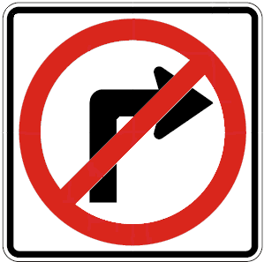
1. What is the meaning of this sign ?
1

1
Don't turn right .
6

6
2. Which city would you like to visit ?
1

1
Any suitable city

3. Who was your best friend in elementary school ?
1

1
Any name.
B) Put ( √ ) or ( X ) for each sentence :
1

1
1. The fastest animal in the world is an elephant. ( X )
1

1
2. The biggest animal in the world is the blue while. ( √ )
3. There are three main directions . ( X )
1

1

3-A) Choose the right words :
5

5
1. Where ( was - were - are ) you last week ? ½
2. Salem ( goes – go - went ) to school yesterday. ½
***********************************************
B) Complete the table :
Adjectives | Comparative form  ½ | Superlative form  ½
tall | taller than | the tallest
expensive  ½  ½ | more expensive than  ½ | the most expensive  ½
good | better than | the best

C) Underline the (direct object) and circle the (indirect object) :
½
1. She gave some money to Nada.
½
2. The teacher wrote the sentence on the board.
6

4-A) Match the words with their pictures :
1. diamond / 2. talkative / 3. No swimming / 4. Pyramids / 5. cough / 6. Go straight



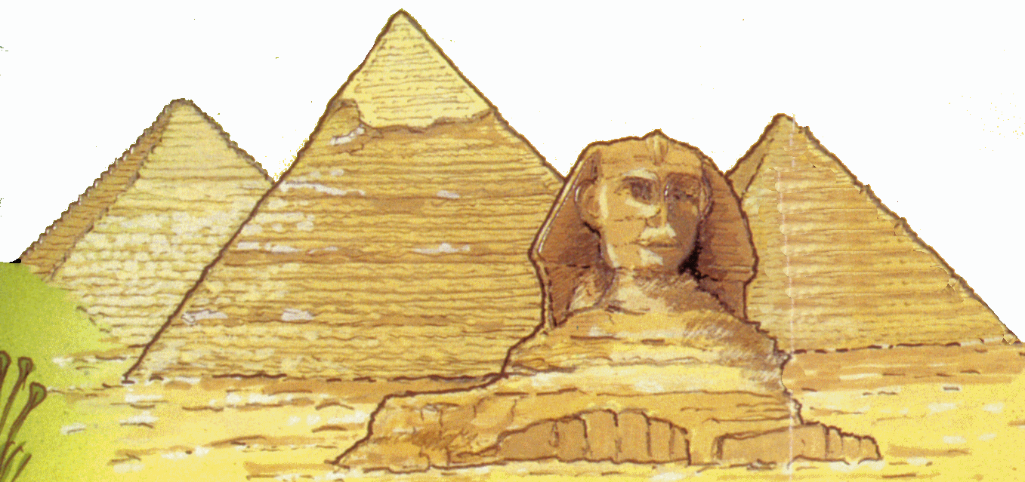

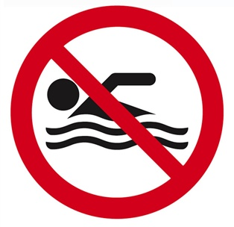

1

3
2
6
5
4
1

B) complete the spelling of these words :
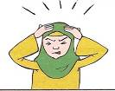

1. square. 2. happy. 3. dizzy. 4. triangle.
15

15
1

1
1

1
1

1
1

1

C) Copy the following (ONCE) :

5

