Name : …………………………… Class : ………………
How is your result ?
  try harder |   well done
worksheet : ( )

Color and match :
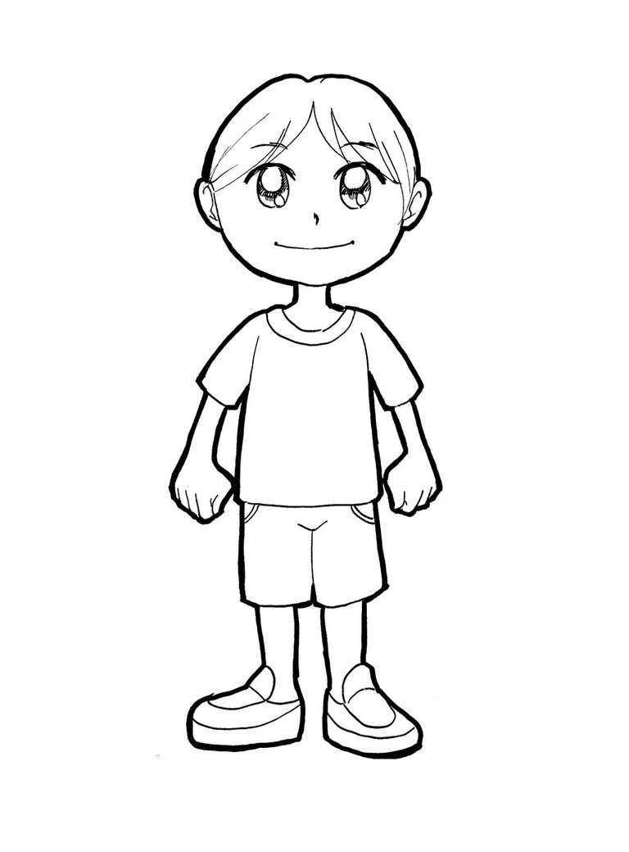
T-shirt
Shoes
Football
Jeans

